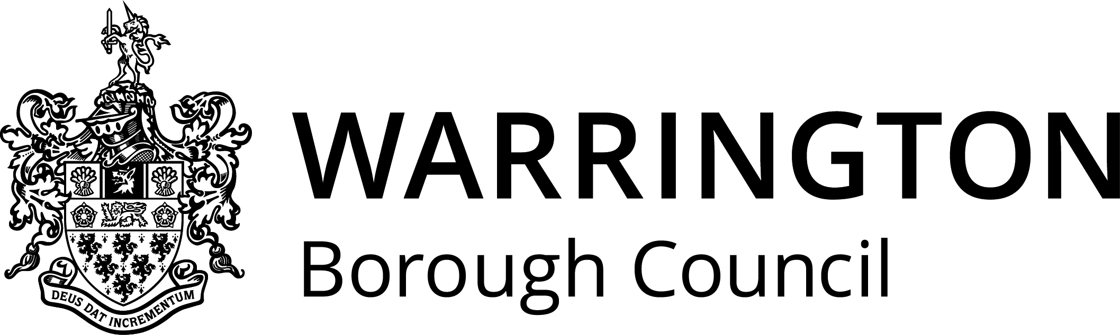

Dear parent/guardian
Warrington School Meals Service would like to thank you for your continued custom. Our new spring/summer menu will begin week commencing 13th March. This will be available to view on the Warrington Council Website, address below.
We have been working closely with The Soil Association to comply with the criteria for the ‘Food For Life Served Here Catering Mark’. This provides an independent verification that food is fresh, sustainable and from traceable sources. We will update you in due course when we have gained accreditation.
Over 75% of the dishes on our new menu are freshly prepared daily using fresh, sustainable ingredients which are free from harmful additives, meat and meat products are Red Tractor/Farm Assured, Fish is MCS certified and only free range eggs are used in our dishes. This is good news for animal welfare!
Fresh food that meets nutritional guidelines in schools can lead to better concentration and performance in the classroom, as well as positively influencing eating habits in later life.
We hope your child will enjoy the new spring/summer menu and we thank you again for your support.
Warrington School Meals Service Team
Tel: 01925 443082
https://www.warrington.gov.uk/info/201087/schools_and_learning/500/school_meals

