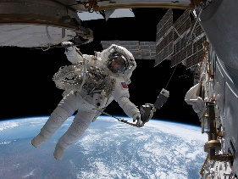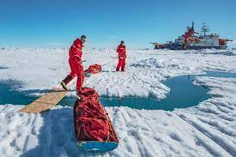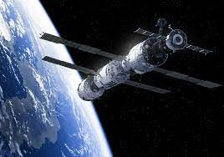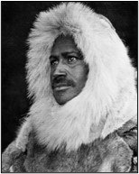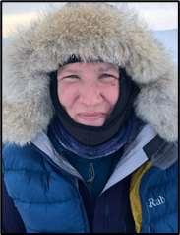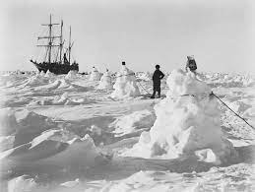

**Questions we will investigate on**

**our learning journey:**

* Who are explorers and what do they do?
* Who was Matthew Henson and what did he do?
* Who was Felicity Aston and what did she do?
* How do we know about these explorers?

Skills we will use on our learning journey:

reading

sequencing

reasoning

recount

research

explaining

Question I would like to ask:

Vocabulary we will use on our

learning journey:

achievement

astronaut

equipment

expedition

explorer

polar

significant

past

present

**What does it take to be a great explorer?**

?

**BIG PICTURE**