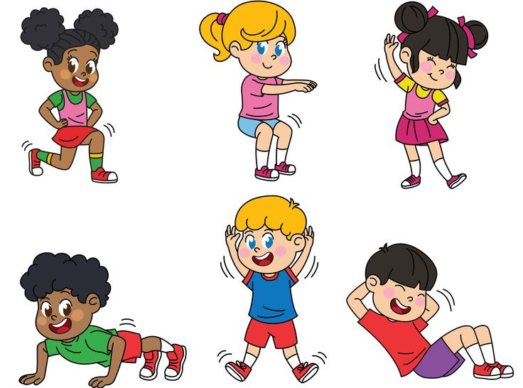

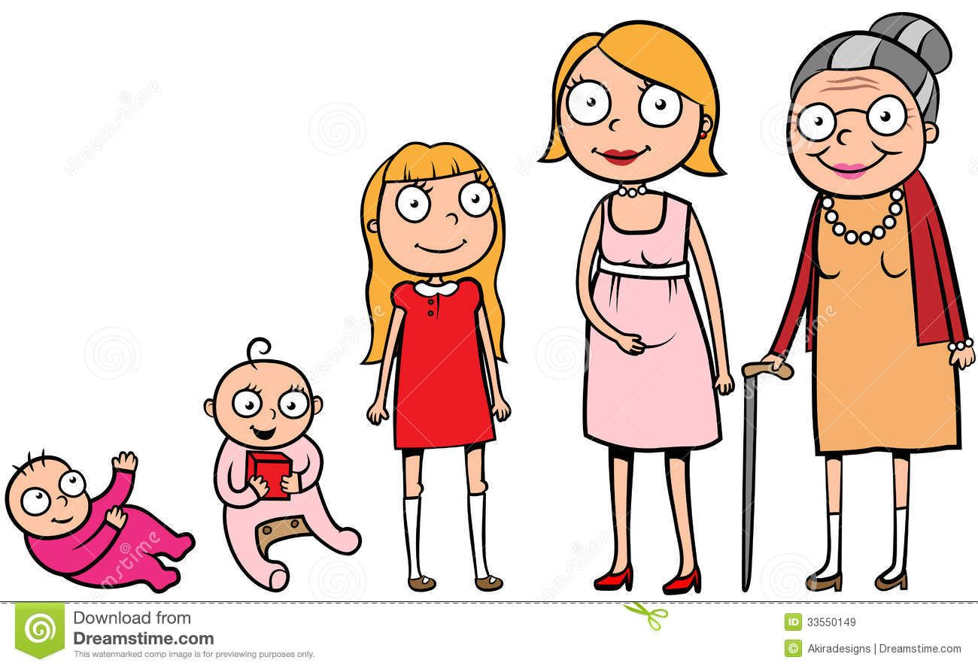

Big Picture

**Why is it important to keep our bodies healthy?**

**Questions we will explore…**

**\*What do we mean by a balanced diet ?**

**\* Why is it important for humans to have a balanced diet?**

**\*Why is exercise and good hygiene important for humans?**

**\*Who is the fittest in our class?**

**\*What are the main stages of growth from babies to adulthood, in humans and in animals?**

**Vocabulary we will use…**

**protein fats**

**nutrition carbohydrates**

**offspring hygiene**

**healthy balanced diet**

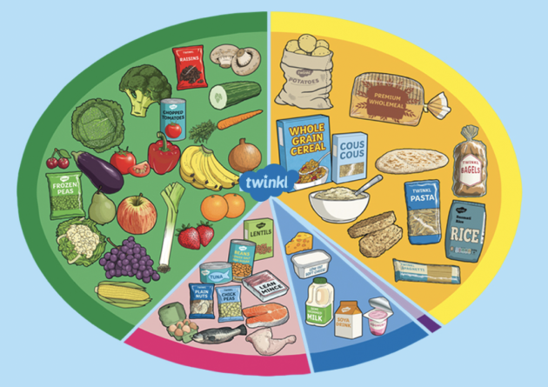

**:Skills we will use:**

**Talk partners, research, grouping and classifying, observing, drawing, discussing, writing.**

**Question I would like to ask…**