Friday, 22nd January, 2021

LO. To comprehend.

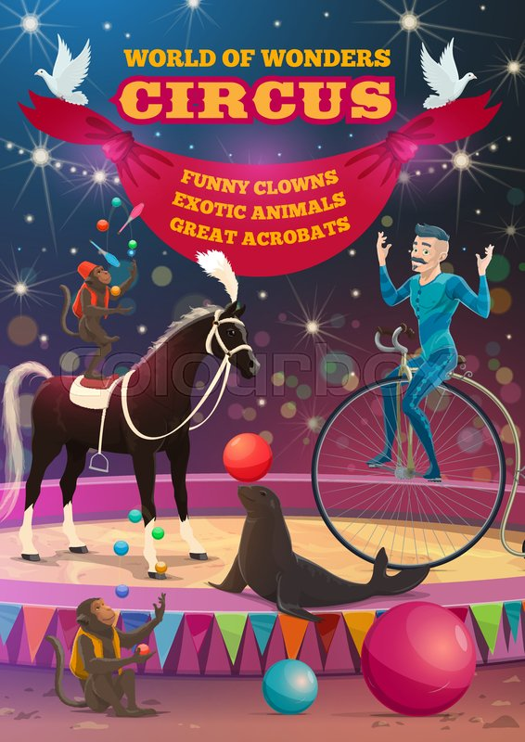

1. What are the monkeys doing?
2. What is the figurative expanded noun?
3. What other acts preform at the circus?
4. What do you think this image is used for?
5. Why do you think the illustrator has used bright colours?

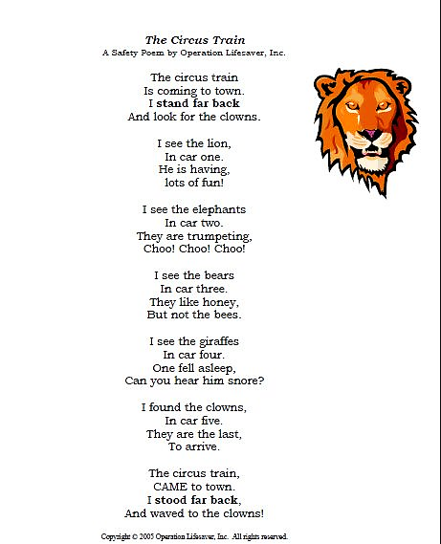

1. Who is the author of the poem?
2. Why do you think this poem has been created?
3. What are the elephants doing in their car?
4. Why has the author put ‘ I STOOD FAR BACK’ in capital letters?

**PUSH IT!**

Can you create another verse to add to the poem?

Let’s model…

I see the horses,

In car forty.

They are trotting,

Clip, Clop, Clopping!

