Were the Anglo Saxons really smashing?

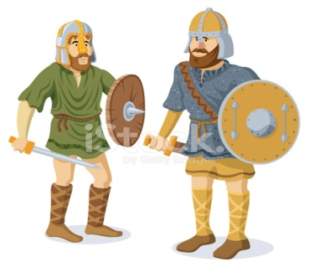
Questions we will explore;
- Who were the Anglo-Saxons and how did they influence our life today?
- How did the Anglo-Saxons bring law and order to Britain?
- What evidence do we have today that the Anglo-Saxons were ever here in the first place?
- Which Anglo-Saxon Christian symbols remain with us today?
- Can you create your own Anglo-Saxon art focusing on tessellations?
- Who were the famous Anglo-Saxons and why was Alfred so ‘great’?

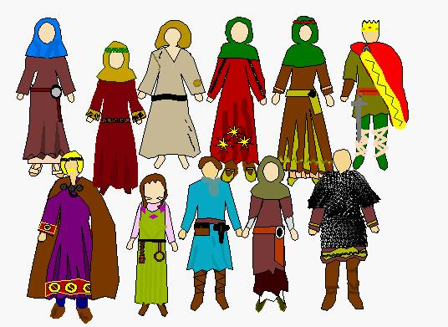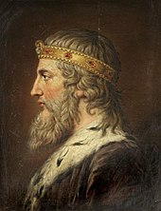
Skills we will use: Research including ICT
Debate and discussion
Reflection
DT- use of tools
Reading and evaluating
Atlas work
Vocabulary we will use:
Timeline, chronological, civilizations, runes, longhouse, Odin, Danelaw, Battle of Hasting, King Alfred the Great,
Questions I would like to ask?

