LO: To assess prior learning

LO: To research
What can we find out about the history of graffiti and famous graffiti artists?

LO: To imitate
Can we record aspects of graffiti art we particularly like?

LO: To design a tag

Retention quiz

 | a. | b. | c.
 | a. | b. | c.
 | a. | b. | c.
 | a. | b. | c.
 | a. T | b. | c.

Can you spray that again please?
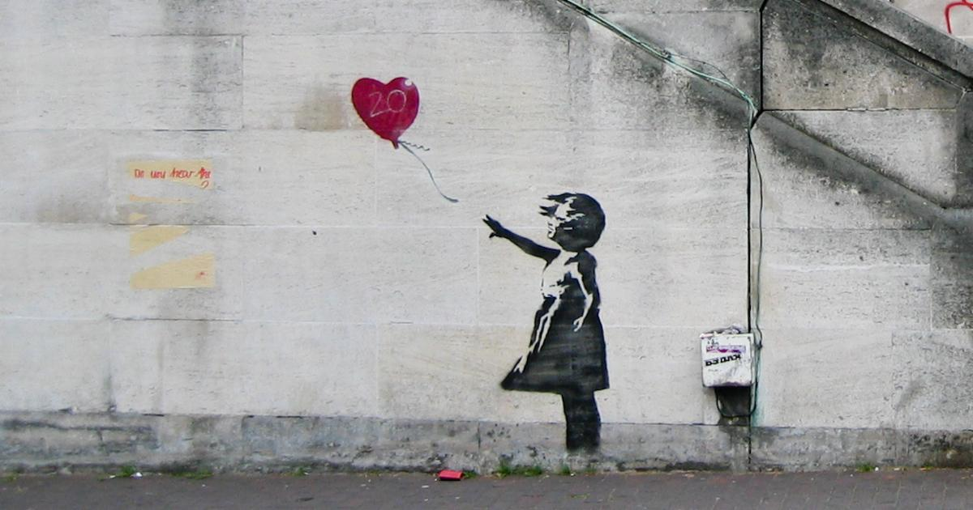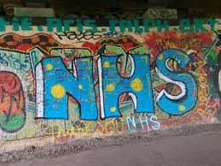
Topic Feedback:
- What can we find out about the history of graffiti and famous graffiti artists?

- Can we record aspects of graffiti art we particularly like?

- Can we design and paint our own tag?

- Which piece of graffiti art will we copy using paints?

Reflection: What laws would we change or make about graffiti?

What I liked about the topic:

What I would do to make it even better:

