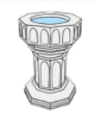

**Christian Values**

Faith

Respect

**Question I want to ask :**

**Vocabulary we will use:**

chapel cathedral sacrament vicar

curate

priest

minister

denomination

synagogue

mosque

What does ‘church’ mean?

Are all churches the same?

Who was Peter ?

Where do people of other faiths worship?

**Big picture**

**Are all churches the same ?**

**Key skills we will use:**

read

discuss

compare

reflect

investigate

record

enquire