Year group | Topic and Big Question  Core knowledge history overview ( updated Aug ‘23) | Core knowledge | Disciplinary knowledge in history | Substantive concepts | Assessment outcome – exit task
1/2 A | Transport  How did people travel through History? | - Has it always been easy to travel ?  - How have cars,buses,trains,bicycles and planes changed throughout history ?  - Can you design and make a vehicle that can move?  - What was the Titanic and why do we still talk about it today ?  - What was different about being a first or third class passenger ? | Continuity and change  Similarity and difference  Historical  significance  Chronology  sources | Society  voyage | I can show that I know about different types of transport over time.
 | Social history -1950s ( living memory )  What was it like when the Queen came to the throne in 1953? | - To know what a King or Queen does  - To investigate the monarchy family tree and make one of our own  - To know what a coronation is and explain what happened in 1953.  - To begin to use a timeline to place events.  - To design a flag for our own coronation? (linked to Art)  - To use sources to investigate what life was like in the 50’s – home and food,school and toys,  fashion and music.  - To pose questions and interview someone who experienced life in the 1950s. | Sources  Interpretation  Historical  significance  chronology  Continuity and change  Similarity and difference | Society  monarchy | I can share my knowledge about the Queen’s coronation.
 | Exploration  What does it take to be a great explore ? ( Matthew Henson and Felicity Aston) | - Who are explorers and what do they do?  - Who was Matthew Henson and what did he do?  - Who was Felicity Aston and what did she do?  - How do we know about these explorers? | Chronology  Sources  Change and continuity  Similarity and difference | conquest  voyage | I can share my knowledge about famous explorers from the past.
B | Social history  What has changed since my grandparents were young? (60’s/70’s) | - To know who my grandparents are  - To place my grandparents birth, my parents birth and my birth on a time line .  - To find out what toys my grandparents played with when they were young  - To find out what clothes they wore when they were young (fashion)  - To find out what TV programmes and music they enjoyed when they were young  - To investigate what school would have been like when my grandparents were young  - To identify what has changed since my grandparents were young | Sources  chronology  Similarity and difference  Continuity and change | Society | I can show that I know how life in the 1960 and 1970ss was different to life in the present.
 | Significant individuals-living memory  How have people helped to make the world a better place? | - To know who Florence Nightingale was and how she made hospitals cleaner and safer.  - To know who Emily Davison was and what she did to support Women’s rights.  - To know who Oskar Schindler was and how he helped Jewish people in WW2.  - To know who Martin Luther King was and how he campaigned for freedom and equality.  - To know who Jane Goodall is and what she has done to inspire people to look after our animals and our planet  - To place these significant individuals in chronological order on a timeline.  - To reflect on how I may make the world a better place when I am older . | Similarity and difference  Continuity and change  Sources Chronology  Historical  significance | Freedom  Rights  Society | I can show my knowledge and understanding about significant individuals and what cause they were fighting for.
 | Victorians -changes beyond living memory, our own locality  What were the people who lived in our town/city like 150 years ago? | NB To be replanned with more local history focus 2024 | Sources  Similarity and difference  Cause and consequence  Chronology | Monarchy  Society  Empire | I can show my knowledge and understanding of what life was like in the Victorian era.
3/4 A | Stone Age  Who first lived in Britain ? | - To know the Stone Age was split into 3 parts  - To place Stone age eras on a timeline  - To understand the role of the archaeologist  - To describe the types of shelters people from the Stone Age used  - To explain how people from the Stone Age obtained food  - To describe the dangers faced by people from the Stone Age  - To know how early Britons developed from the Palaeolithic age up to the Iron Age | chronology  interpretation  sources  continuity and change  Historical  significance | Settlement  Civilisation  society | I can demonstrate that I understand some of the changes in Britain that happened between the Stone Age to the Iron Age.
 | Ancient Egypt  Would I like to have been an Ancient Egyptian ? | - To place the Ancient Egyptians on a timeline.  - To use artefacts to learn about this period.( role of archaeologist, Howard Carter)  - To investigate why the River Nile was so important to the people of Ancient Egypt.  - To know what beliefs the people of Ancient Egypt had.  - To explain the process of mummification and know why the Ancient Egyptians did it.  - To understand the purpose of the pyramids.  - To explain how society was organised in this period | Chronology  interpretation  sources  cause and consequence  Historical  significance | Civilisation  Society  Religion | I can demonstrate that I understand what was most important to people in Ancient Egypt.
 | Normans  Why did the Normans build so many castles? | - Who was William the Conqueror and why is 1066 a famous date in British history ?  - Why did the Normans build so many castles ?  - What is the Doomsday Book and do we have something similar today ?  - What changed in Britain as a result of the Norman conquest ? | sources  interpretation  Cause and consequence  Continuity and change  Historical  significance | Conquest  Power  monarchy | I can share my knowledge and understanding about the impact the Normans had on life in Britain during this period.
B | Ancient Greece  Why are we still talking about Ancient Greece ? | - To place the Ancient Greek period on a timeline  - To use artefacts to infer about life in Ancient Greece  - To know that Ancient Greece was split into city states  - To compare life in Sparta and Athens ( incl democracy)  - To investigate whether Alexander the Great was indeed great.  - To identify the influence of the Ancient Greeks on our lives today. | Chronology  Sources  Interpretation  Cause and consequence  Similarity and difference  Historical  significance | Civilisation  Democracy  Empire  power | I can demonstrate that I understand about life in Ancient Greece  I can demonstrate that I understand the achievements of Ancient Greece and their influence on the western world.  .
 | Romans  What did the Romans ever do for us ? | - To place the Romans on a timeline  - To know the reasons why the Romans came to Britain  - To understand and empathise what it is to be invaded  - To explain why the Romans built forts  - To know who Boudicca was and what she did  - To identify the legacy the Romans have left for us.  Geography link – mapping  skills – locations of main Roman forts in Britain, route Boudicca took, Hadrian’s wall and main Roman roads | Chronology  Cause and consequence  Sources  interpretation  Continuity and change  Historical  significance | Civilisation  Empire  Conquest  Tribes  Society  Power  conflict | I can demonstrate that I understand about the history of the Roman Empire and its impact on Britain.
 | Crime and punishment  Who were the early law makers ? proposed name change to – Does the punishment fit the crime? | - How were people in Roman Britain punished?  - How were suspects dealt with in the Anglo Saxon period?  - What did the Tudors do to keep law and order ?  - What changes occurred in the Victorian period ?  - To plan , design and host a class exhibition for wider school community | Cause and consequence  Similarity and difference  Continuity and change  Sources  Historical  significance | Society  Power  Rules and laws | I can demonstrate that I know about the changes that have occurred over time regarding crime and the types of punishments given.
5/6 A | Mayans  Who were the Mayans and what have we learnt from them ? | - To know who the Mayans were, where they lived and when they lived.  - To use evidence to prove that the Mayans were an advanced civilization.  - To investigate what the Mayan civilization have in common with space travel.  - To identify what we can learn from the way they built their pyramids.  - To explain the rituals carried out by the Mayan civilization.  - To know why was the Sun an important feature in Mayan life.  - To identify and explain the reasons the Mayan Civilization disappeared. | Sources  interpretaion  chronology  Cause and consequence  Continuity and change | Civilisation  Religion  society | I can demonstrate that I understand about the achievements of the earliest civilizations.
 | Anglo-Saxons  Were the Anglo-Saxons really smashing ? | - To know who the Anglo-Saxons were and when they lived.  - To investigate what evidence we have today that the Anglo-Saxons were ever here in the first place.  - To understand how the Anglo-Saxons brought law and order to Britain.  - To investigate which Anglo-Saxon Christian symbols remain with us today.  - To create your own Anglo-Saxon art focusing on tessellations.  - To know the famous Anglo-Saxons and why Alfred was so ‘great’  - To identify how did they influence our life today. | Sources  interpretation  Change and continuity  Cause and consequence  Chronology | Society  Religion  Rules and laws  monarchy | I can demonstrate that I understand the history of Britain’s settlement by Anglo-Saxons
 | Vikings  Were the Vikings always victorious and viscous ? | - To know who the Anglo Saxons were and whether they liked the Vikings or not.( recap from previous topic- links)  - To place the Vikings invasion of Britain on a time line.  - to understand how sources are used to inform us about the past.  - To know why the Vikings came to Britain and how they made the journey.  - To investigate what the native Britons learnt from the Vikings.  - To know how the Vikings lived when they came to Britain.  - To describe the features and functions of a Viking long boat.  - To investigate the legacy of the Vikings | Similarity and difference  Sources  interpretation  Change and continuity  Cause and consequence  Chronology | Settlement  Society  conflict | I can demonstrate that I know why the Vikings settled in Britain and what they did whilst they were here.
B | World war 2  How and why did WW2 start? | - What does ‘war’ mean?  - What happened in Munich in 1938 (and why did Britain feel betrayed by Hitler?)  - Why did World War 2 start and what part did Hitler have in it?  - Why is the Battle of Britain significant in World War 2?  - Who was Winston Churchill and what part did he play in the war?  - Why was propaganda important? | interpretation  Cause and consequence  Sources  Chronology  Continuity and change  Historical  significance | Conflict  Nationality  Power  Empire  freedom | I can demonstrate my knowledge and understanding of why WW2 started and the impact of Hitler’s policies.  I can explain why propaganda was used during WW2.
 | Slavery  Why should the world be ashamed of slavery ? | - To investigate why slavery has existed and what we know about it.  - To understand the link between slavery and discrimination  - To identify some famous people who have fought against discrimination.  - To reflect on whether Britain can be described as a multicultural society.  - To empathise with emotions associated with slavery to produce a piece of art. | Sources  Change and continuity  Cause and consequence | Society  Slave  Trade  Migration  freedom | I can demonstrate my knowledge and understanding of the impact slavery had on different groups in society.
 | Islamic golden age  Why was the Islamic civilisation known as the ‘Golden Age’? | - What did this ‘Golden Age’ give the world?  - Who is the Prophet Muhammad and how was he associated with the ‘Golden Age’?  - What part did the ‘Golden Age’ have in improving health care?  - What can you discover about the art and culture of the ‘Golden Age’?  - Why did the ‘Golden Age’ come to an end? | Sources  Interpretation  Cause and consequence | Society  Religion  civilisation | To share my knowledge and understanding of the legacy of the Islamic Golden Age.
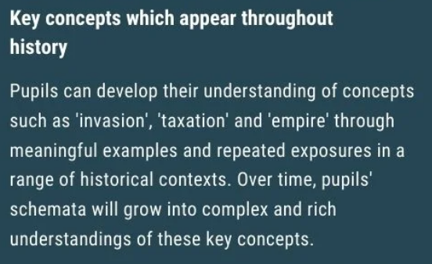
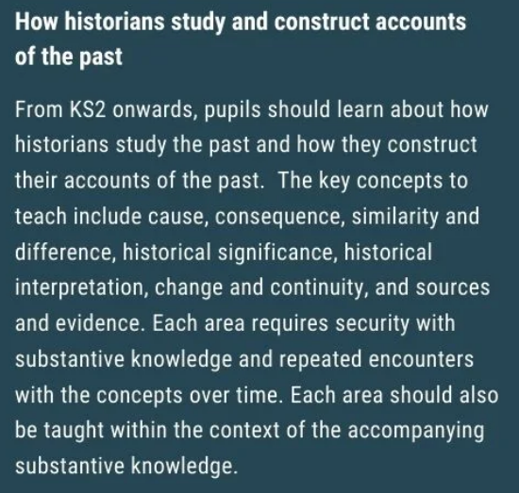
Substantive concepts
Disciplinary knowledge in history

