Big Ideas.
Key Vocabulary
Recycle | To use something again, sometimes for a different purpose.
Conserve | To protect something from harm of destruction.
Pollution | A substance that is harmful to the environment, for example, spilling oil into the sea.
Non-renewable Resource | A resource that will run out fi we use it all e.g., coal.
Renewable Resource | A resource that doesn’t run out e.g., energy.
Natural Resources | Materials we can use that are from nature, e.g., we can use wood from trees.
Manufactured Resources | Materials we can use that people make, e.g., plastic.
Why do we recycle?
- Conserves energy.
- Reduces waste sent to landfills and incinerators.
- Prevents pollution.
- Conserves natural resources.
- Conserves energy.
- Creates jobs, producing economic benefits.

What can we recycle?
How do we recycle?
Plastic | Cleaned and sorted, then shredded or melted before finally being moulded into new products.
Glass | Crushed, sorted, cleaned, and then mixed. Finally, melted and shaped into moulds to make new bottles and/or jars.
Paper | Separated into different types and grades. Then processed at a mill.
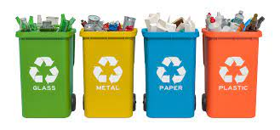

Where can you recycle?
- At home using the correct recycling system
- Recycling plants
- Recycling bins (supermarkets)

