  - 7



‘Growing together at the Heart of God’s Community’
c
10th July 2026 - Our “Value for life” is Wisdom
“For the Lord gives wisdom, out of his mouth comes knowledge and understanding" Proverbs 2:6
Class 2: Reading at the Heart of our school
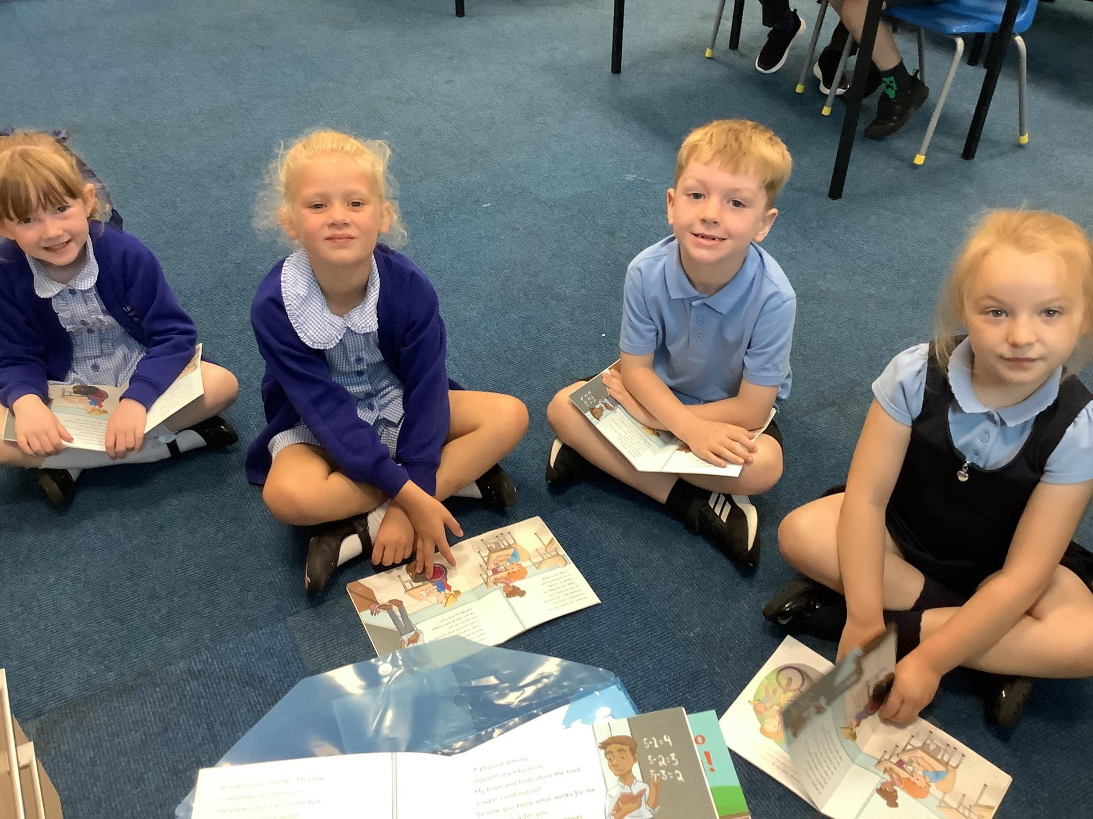

Class 3: Ice Pops after rounders.


Reception: Pirate Portraits
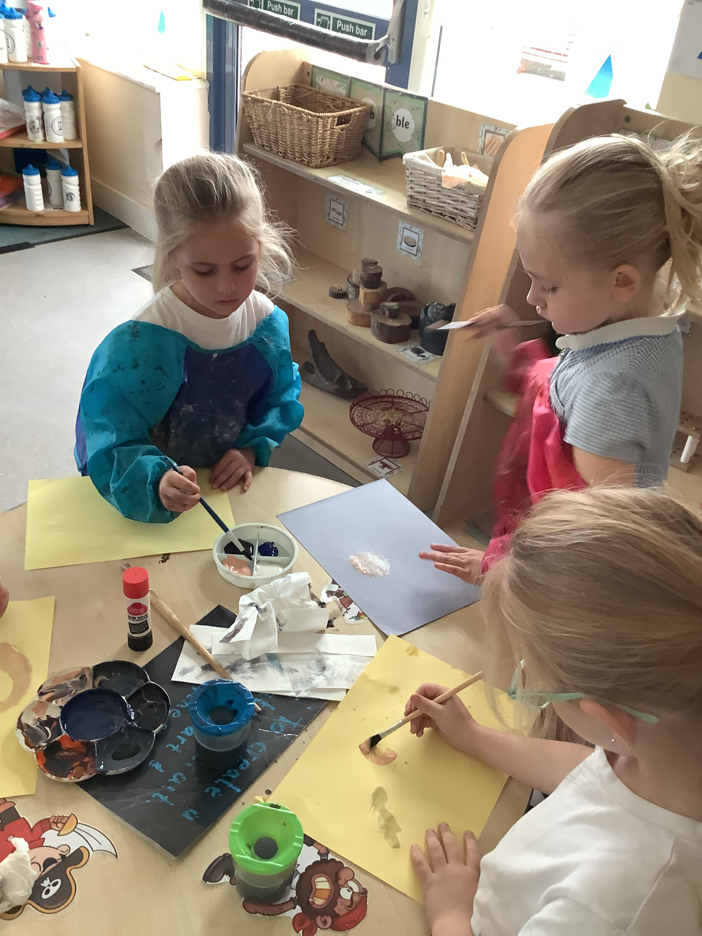

Class 3:Distributive Law
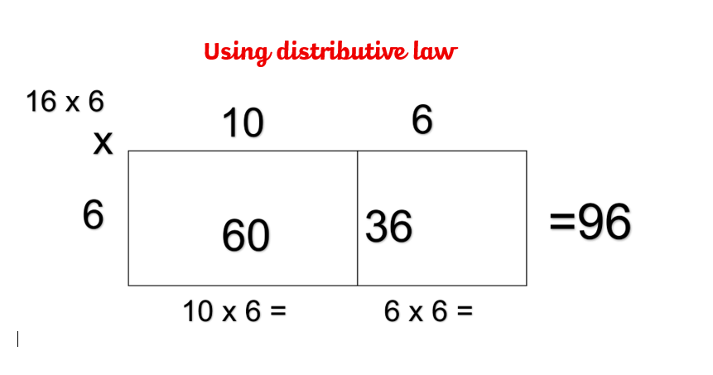

Head Teacher’s Hello 

It has again been a busy week with sports days, assemblies and auditions! One of the real highlights of this week was our wonderful Aspiration Afternoon for our Year 5 and Year 6 pupils. We were delighted to welcome parents into school to talk about their jobs and share their experiences of working in a wide variety of careers. From explaining what a typical working day looks like to describing the different skills and qualifications needed, our visitors gave the children a fascinating insight into the world of work. Events like this are so important because they help broaden children's horizons and encourage them to think about the exciting opportunities that could lie ahead. It was fantastic to see the children asking thoughtful questions and showing such genuine curiosity throughout the afternoon. A huge thank you to all of the parents who generously gave up their time to support this event. Your enthusiasm and willingness to inspire our pupils made the afternoon such a success. We are incredibly grateful for your support and are already looking forward to making next year's Aspiration Afternoon even bigger and better. Mr Sharma.

Class 4: Aspiration afternoon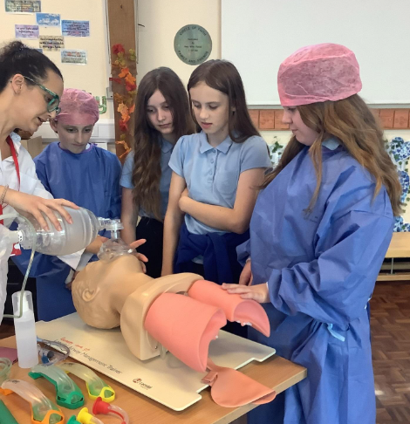

Class 2: Odd & Evan numbers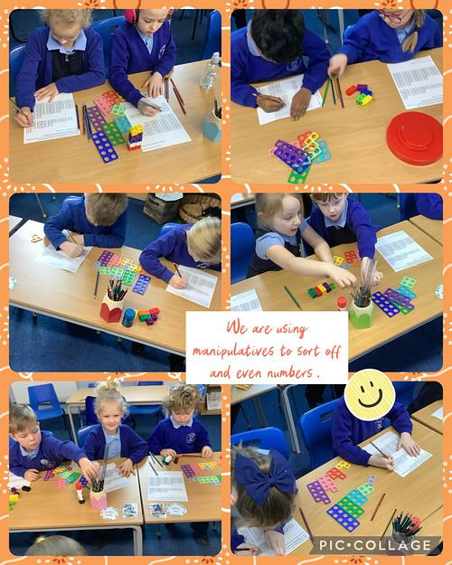s

Week in Pictures

 We are a church school…
Our school value this half term is wisdom

Our Trust’s Prayer 
Heavenly Father,
Let peace, friendship and love grow in our schools.
Send the Holy Spirit to give excellence to our learning,
love to our actions and joy to our worship.
Guide us to help others, so that we may all
Learn, Love and Achieve,
Together with Jesus.
Amen

Learn, Love and Achieve with Jesus …
Raising money for
New Hope School


Glazebury Governors
Chair of Governors – Mr Dave Beechey
Head Teacher – Mrs Karen Mowbray
Staff Governor – Mr Sachin Sharma
Parent Governor – Mrs Amanda Wilcock
Parent Governor – Mrs Jen Morgan
Parent Governor – Mrs Sarah Colbert
Foundation Governors – Ms Sara Makepeace-~Taylor, Mr Stuart Roberts-Tighe, Mr James Towey, Mr Dave Clifton

If you wish to contact them, you can do so via the school email address:
glazeburyprimary@ldst.org.uk



‘Peep into Glazebury History from Logbooks - We are in possession of our school logbooks that date back to July 8th, 1873, before we were even in our school building in 1882. We thought we would share some of the accounts with you each week. .

12.12.1921 – Owing to very dark nights, and no gas available afternoon playtime will be dispensed with, and children dismissed 20 minutes earlier for a few weeks.
16.12.21 – Every wet day has caused a fall in the attendance.

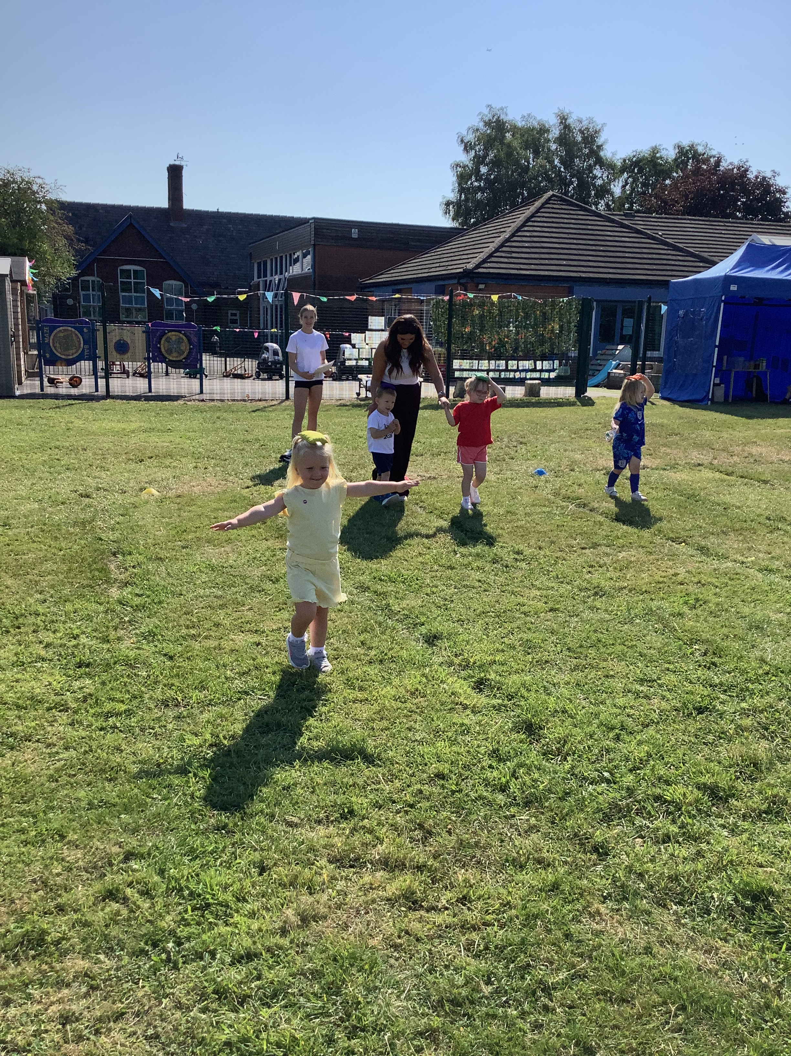
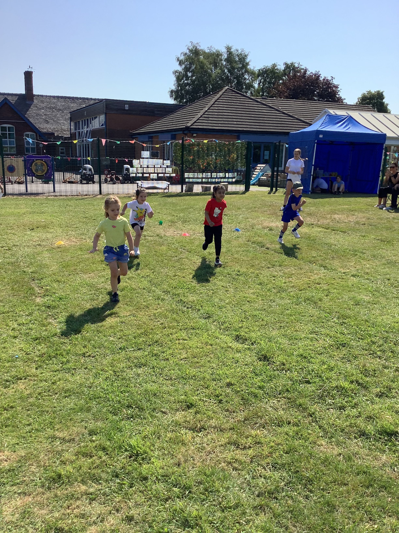

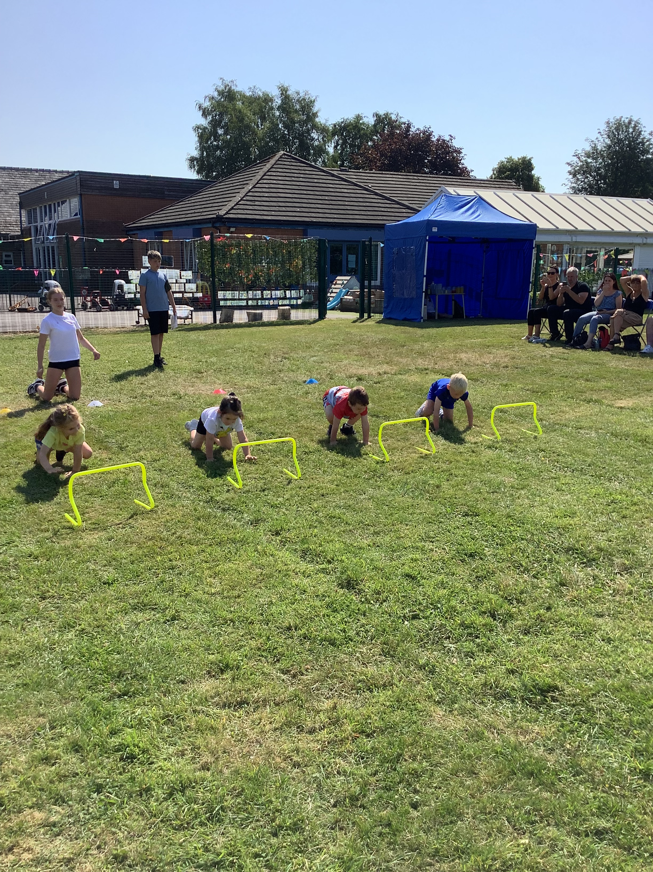

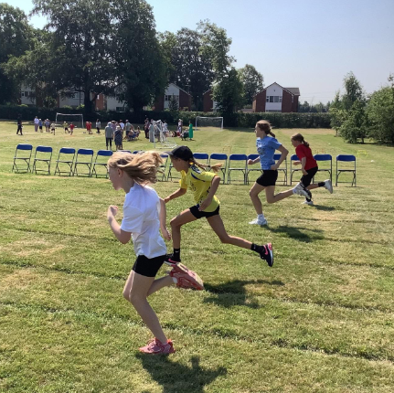
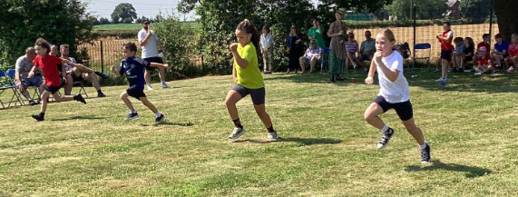
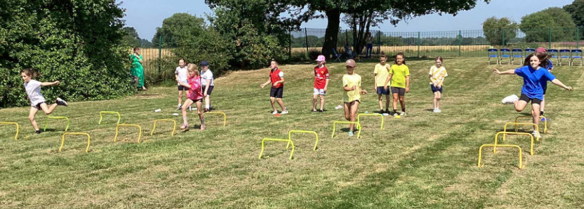
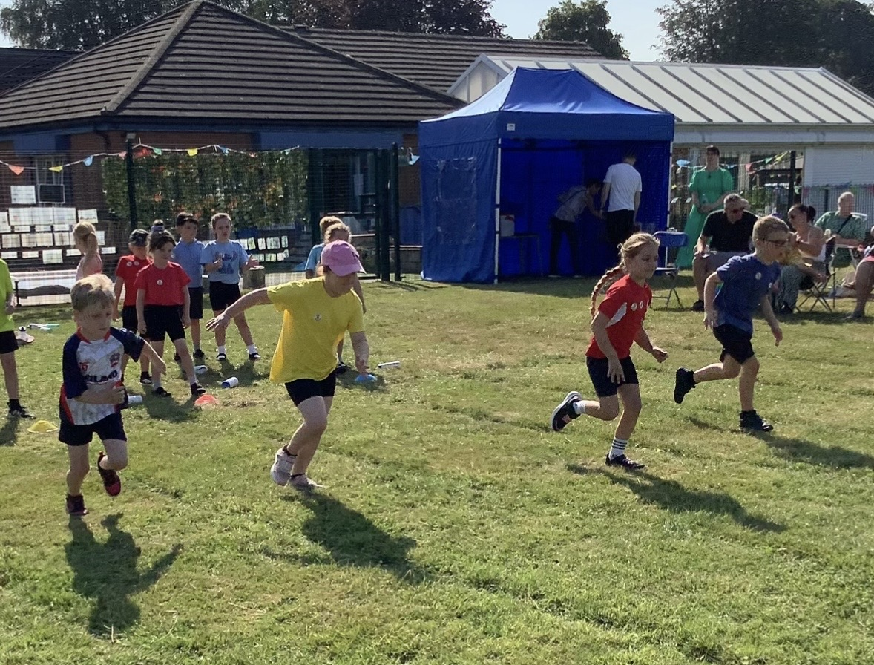

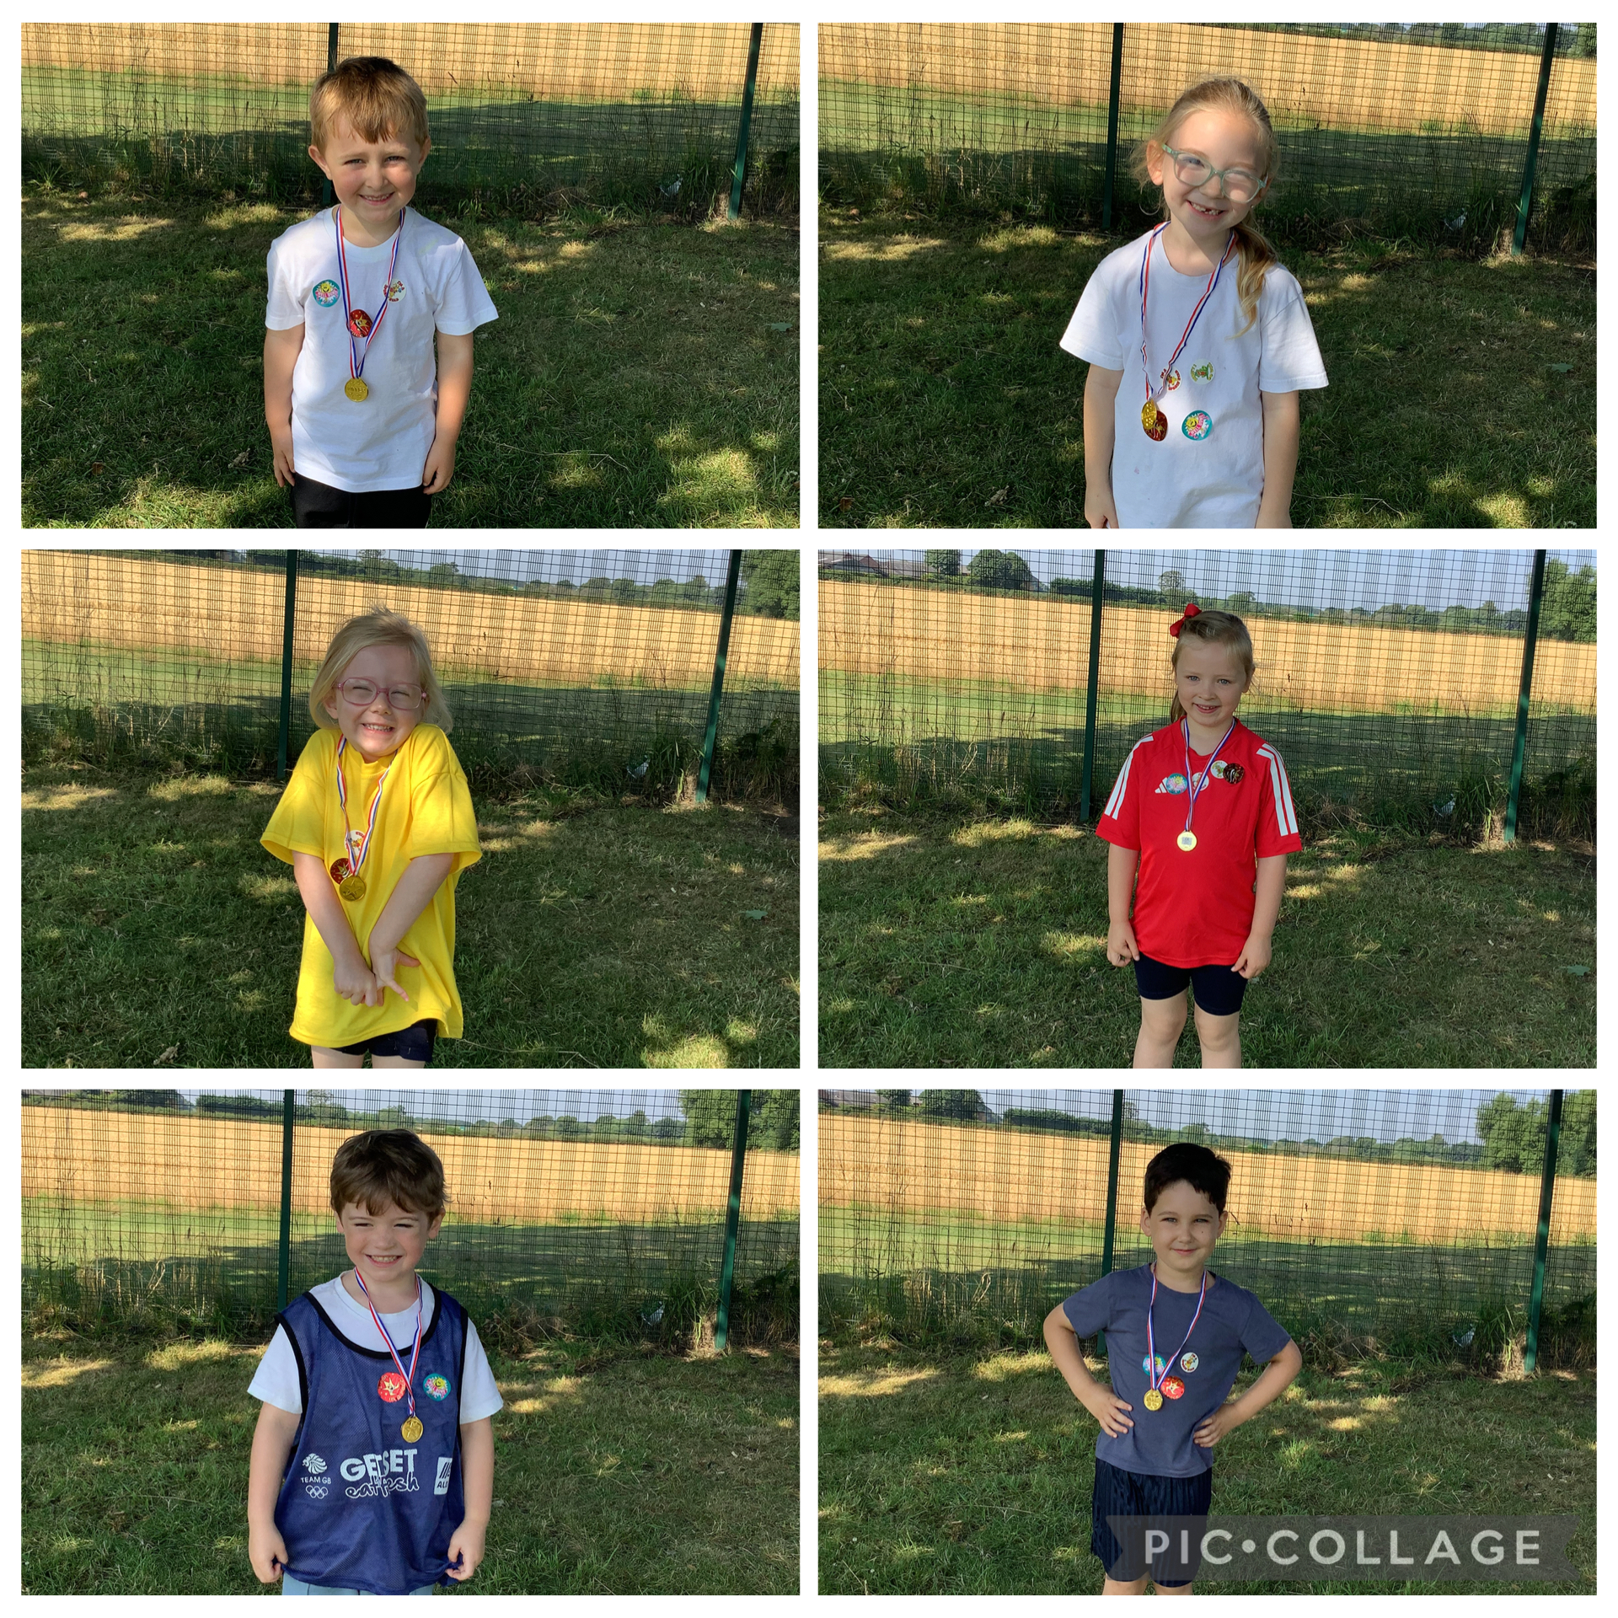


Nursery
Our Nursery Sports Day was a huge success, filled with lots of energy and fun.
We are incredibly proud of our nursery children.
Thank you to all our families who attended and made the day memorable.

Year 1 to Year 6

What a fantastic sports day we are enjoying today our children are filled with energy, enthusiasm, and team spirit! We are seeing fantastic teamwork, perseverance and fun. We are incredibly proud of all the children for their hard work, resilience, and fantastic teamwork. Their positive attitudes and determination were truly inspiring and a credit to our school community.
A big thank you to all staff, volunteers and families and made the day memorable.

 Beat the Goalie 
Everyone had a wonderful time and enjoyed trying to score a goal. This event raised an amazing £110 this will benefit all children.

It’s Still a Surprise – Goodbye to Mrs Mowbray
We hope to see many of you on Saturday morning on our school field at 11am to 1pm to join our goodbye celebration for our Mrs Mowbray. If you are attending, please arrive at 11am as Mrs Mowbray is arriving at 11:15am.
Children will have their own opportunity to say goodbye to her on the last week of term.



We’re excited to host a circus-themed end-of-term celebration on Thursday 16th July for the children as we finish a fantastic summer together. The day will be full of colour, energy and playful activities outdoors.

🎉 What Children Should Wear
Please send children in bright, comfortable clothes suitable for active play. They will be moving around a lot, enjoying outdoor games, inflatables and creative stations.

🤹 Activities & Entertainment
Children will enjoy a circus-style day including:
- Inflatable fun — safe, bouncy play
- Outdoor games — lively activities and giant games
- Craft stations — colourful circus-themed creations
- Temporary tattoos — fun designs to choose from
- Balloons — bright displays and balloon play
- Sweet cones — a small treat to take home
- Drinks — refreshments throughout the afternoon
- Music — upbeat circus vibes
- Photo booth with props — fun snapshots of their day



IMPORTANT NEW INFORMATION OF CHANGES Pupil Premium and Free School Meals
Warrington Borough Council have advised of important changes to Free School Meals (FSM) and Pupil Premium (PP) from September 2026. Below gives you a simple overview of what is changing and what you need to do.
What is changing:
For 2026/27 academic year, all children attending a maintained school, academy or free school will qualify for FSM if their family receives Universal Credit.

New FSM categories:
There will now be two types of FSM:

Targeted FSM
For pupils whose families receive Universal Credit and earn £7,400 or less per year
Expanded FSM
For pupils whose families receive Universal Credit and earn above £7,400 per year

Important: Only pupils eligible for Targeted FSM will receive PP funding from September 2026
Please apply without delay to check your eligibility
In the first instance you can visit www.warrington.gov.uk/freeschoolmeals
and download / complete the application form.
Or contact the school office who can email or provide a paper copy of the application form.
Any queries, please do not hesitate to contact Mrs Holcroft in the school office.

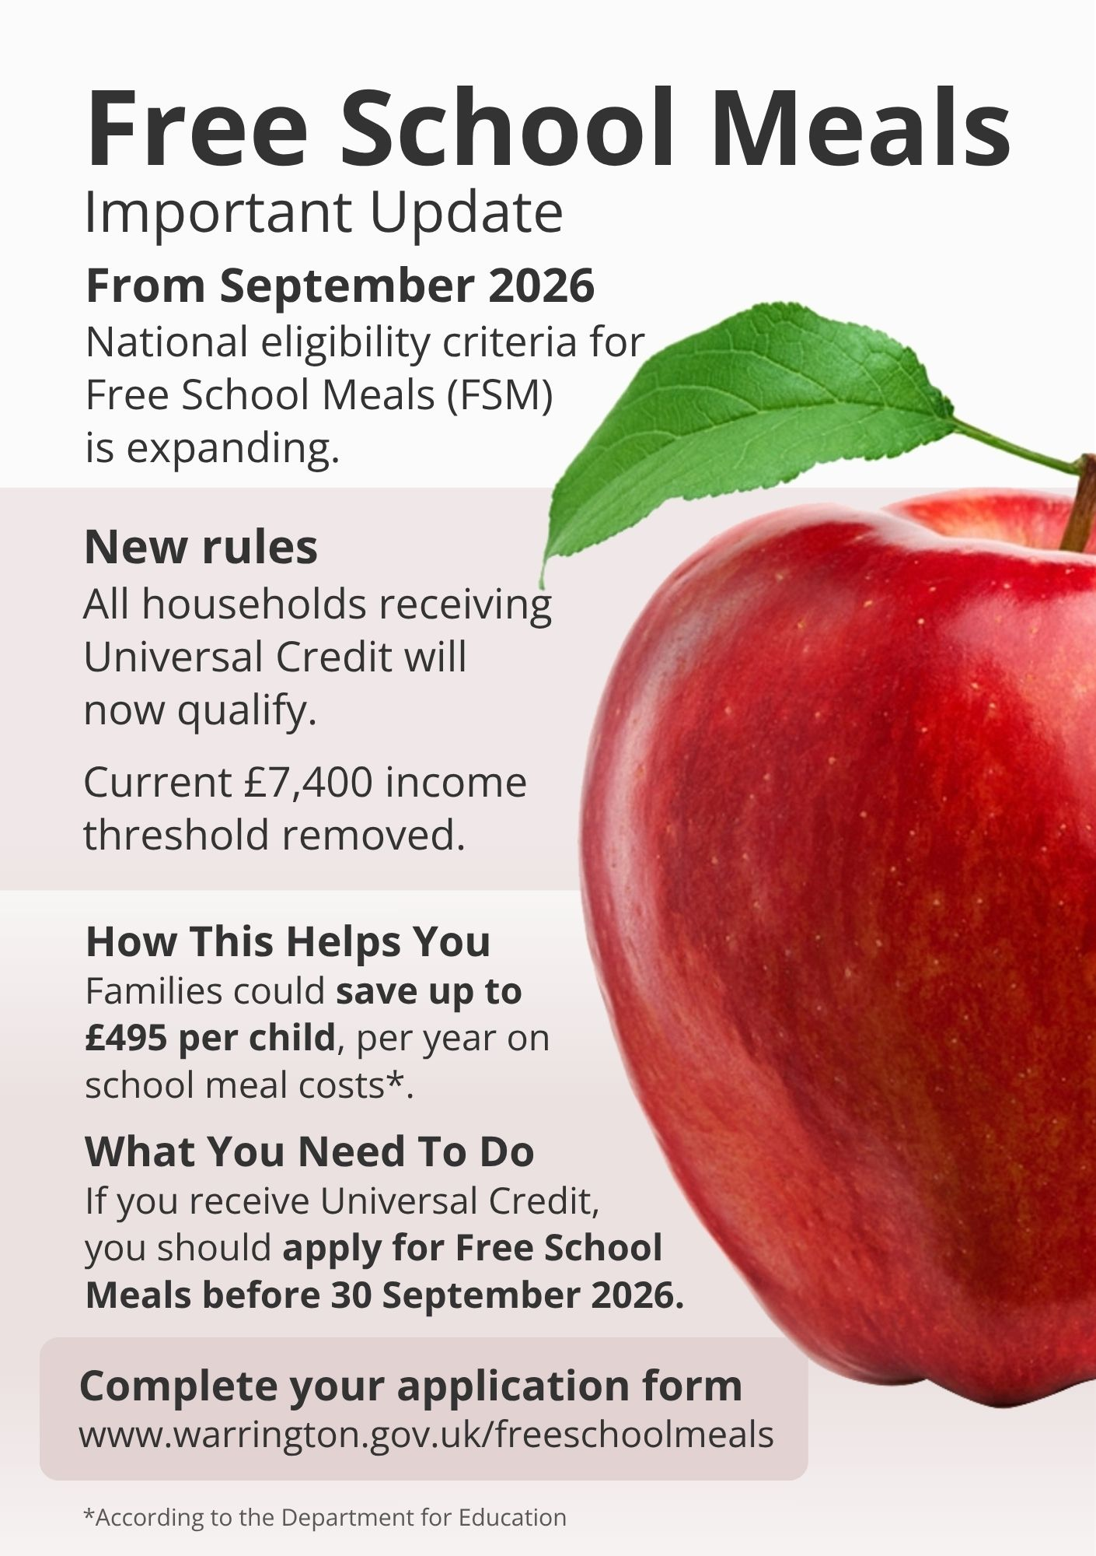


Wrap Around Bookings for September 26
Please ensure you have let the office know your wrap around – breakfast and extended provision requirement for September 26. We can then confirm place allocation as we need to ensure staffing and ratios are in place by Friday 10th July latest.
To secure your place please ensure that payment has been received in advance of accessing the sessions via ParentPay or via childcare vouchers. Please can we remind all that our breakfast club and extended provision club are bookable for the full half term, the clubs are very busy and some days at full capacity, so unfortunately, we are unable to offer drop in sessions.
Please follow the link or QR code below and request your child’s sessions before Friday 10th July.

Wrap Around-Breakfast and Extended Requirements for September 2026 – Fill out form

Collective Worship next week Friday 17th July



We are looking forward to seeing you at Collective Worship next week Friday 17th July, final one of the academic year.

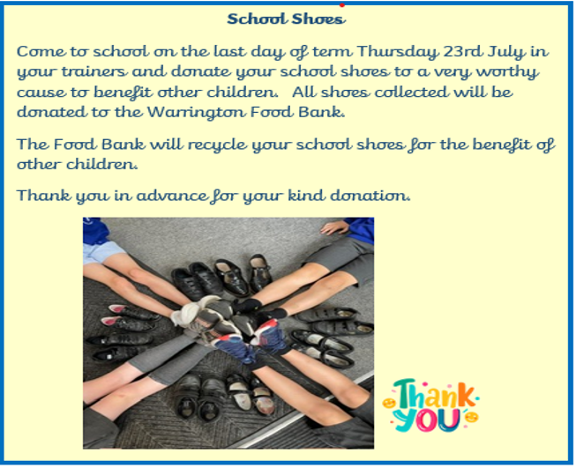









Active Sport PE Star of the Week Award

Well done everyone this week you have been amazing in this hot weather.

You are all stars of the week.


5th July – Thomas - Year 6
5th July - Navani - Nursery

ATTENDANCE
Pupil Attendance Officers – Jaxx Yr 6 and George Yr 5.
Whole school attendance so far, this academic year is 96.5%
Glazebury School attendance target is 97%.
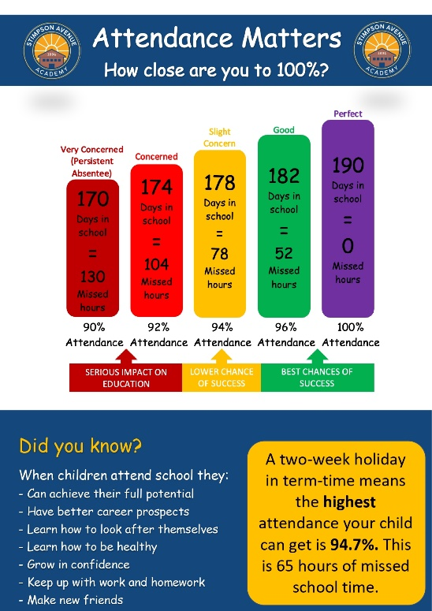
Attendance for week starting Monday 6th July is 97.5%
Attendance in our classes
Miss Delooze - Reception attendance | 100% Well done!
Mrs Tate - Year 1 attendance | 98.5%
Mrs Tate - Year 2 attendance | 96.5%
Mrs Goman- Year 3 attendance | 93.8%
Mrs Goman- Year 4 attendance | 97.7%
Mr Sharma - Year 5 attendance | 100% Well done!
Mr Sharma - Year 6 attendance | 96.9%

