**Religious Education:**

***Exploring the lives of significant women in the Old Testament***

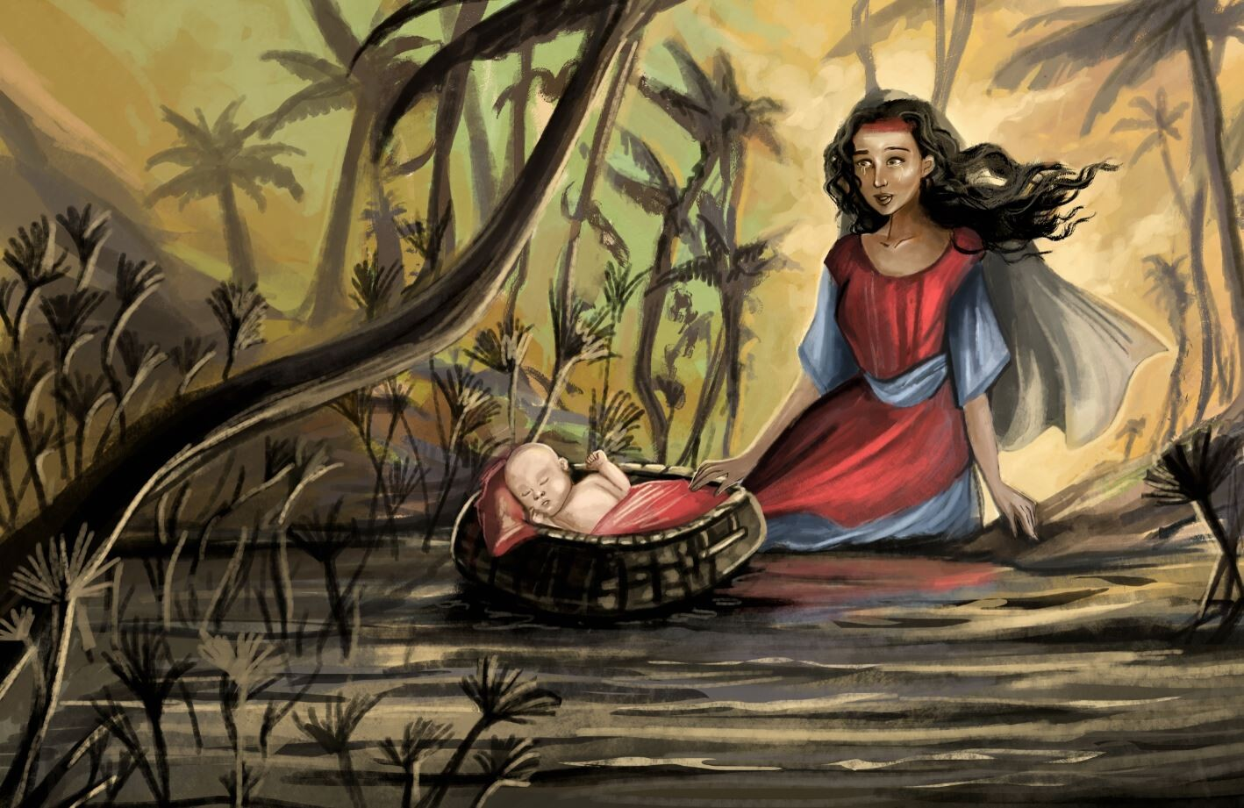

**Skills we will use:**

* Research including ICT
* Reading, and evaluating
* Art
* Debate and discussion
* Discussion/communication
* Reflection

**Vocabulary:**

**Ruth, Esther, Jochebed, Deborah, Purim**

**Questions I would like to ask?**

**Questions we will explore:**

* What can I learn from this story?
* Why is this a significant moment? Why is this woman important?
* In which values and beliefs are the actions of the women rooted?
* Did she do the right thing?
* Where does this story fit into God’s big story?

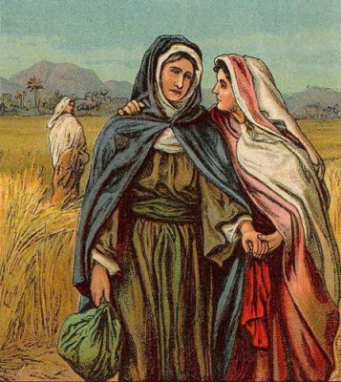

*Ruth and Naomi*

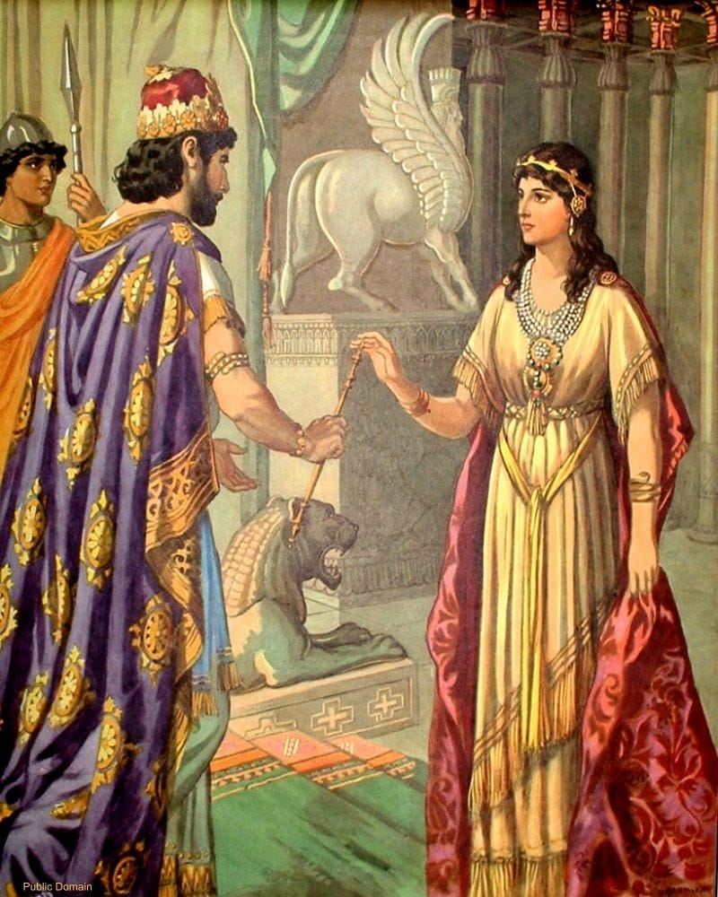

*Esther*