**What would a journey through your body look like?**

[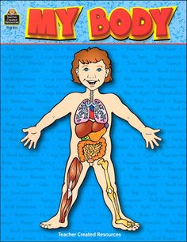](https://www.google.co.uk/url?sa=i&rct=j&q=&esrc=s&source=images&cd=&cad=rja&uact=8&ved=0CAcQjRxqFQoTCIWekZLJ8sgCFcMDGgod1BkMew&url=https://www.pinterest.com/larasplace/human-body-unit/&bvm=bv.106379543,d.dmo&psig=AFQjCNEqKssd0XgYBKkuGX7EyLAYnCevmg&ust=1446582279962035)

Questions I would like to ask...

**Questions we will explore:**

**What is pulse and why do we have one?**

**Why can the heart be described as the most important pump we have?**

**What happens to the oxygen we breathe?**

**Year 5 lesson:**

**What have we learnt from pioneers like William Harvey?**

Vocabulary we will use:

**circulation**

**pulse**

**respiration**

**lung**

**liver**

**kidneys**

**heart**

**oxygen**

**brain**

Skills I will use:

* Observation
* Reflection and evaluation
* Use of IT.
* Art
* Presentation via powerpoint
* History
* Fair Test/Experiments.

[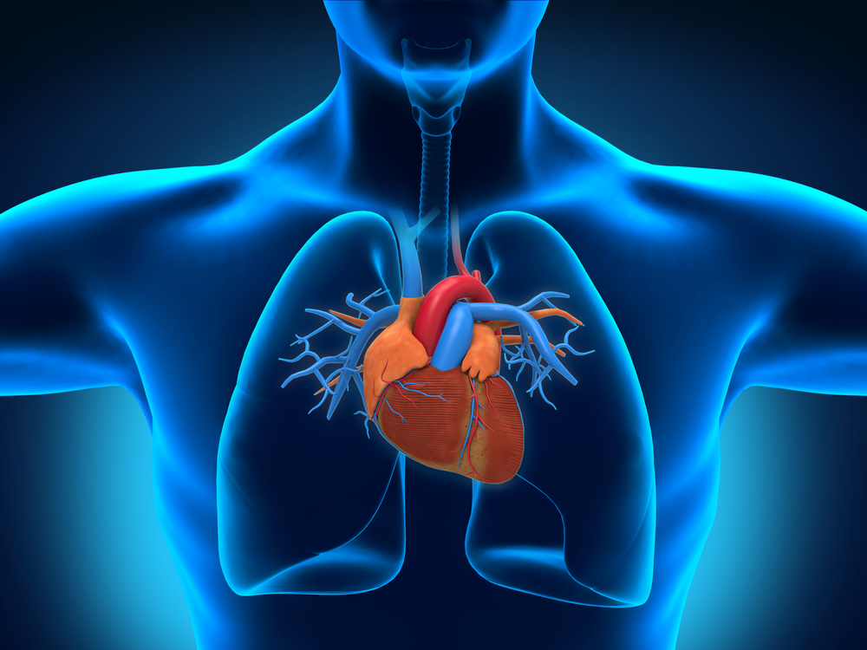](http://www.google.co.uk/url?sa=i&rct=j&q=&esrc=s&source=images&cd=&cad=rja&uact=8&ved=0CAcQjRxqFQoTCLef0YXO8sgCFQEoGgodG30J8g&url=http://www.livescience.com/39925-circulatory-system-facts-surprising.html&bvm=bv.106379543,d.ZWU&psig=AFQjCNGZ36dVzQn8XQw0b1vUITmOn0jzMw&ust=1446583610734557)