**Big Ideas: History –** What was it like when the Queen came to the throne in 1953?

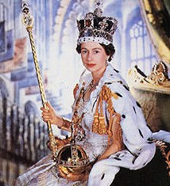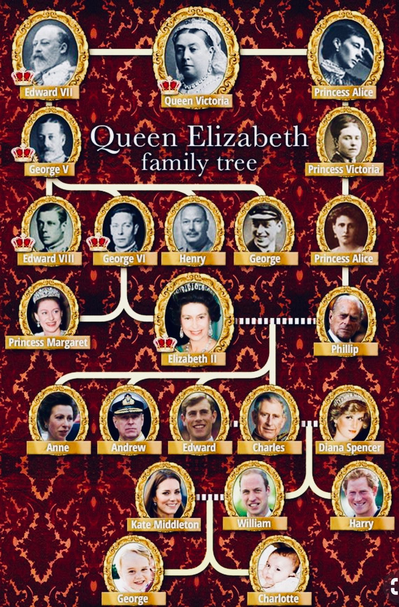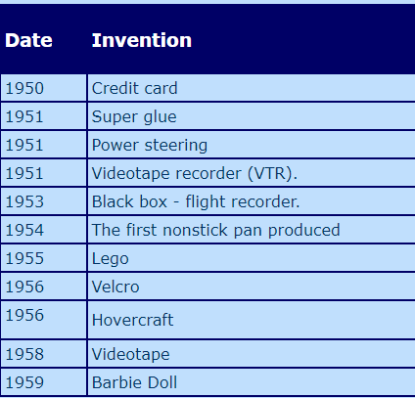

Coronation of Queen Elizabeth II

2nd June 1953

1950s saw the introduction of fish fingers, electric fires, washing machine, ink and toilet paper. In the 1950s, a typical home had a cooker, vacuum cleaner and a plug-in radio, but very few had washing machines and fridge freezers and telephones were very rare.

People spent most of their leisure time at home – reading, listening to the radio, watching television or pursuing hobbies. The most popular hobbies were knitting and needle-work for women, and gardening for men.

Children spent a lot of time playing with other children outdoors. They also enjoyed a range of hobbies such as stamp collecting. Families enjoyed playing board games such as Monopoly, Ludo, and Snakes and Ladders.

There was a craze for yo-yos, 3D-spectacles, I-Spy books and hoola hoops in the late 1950s.