Big Ideas- Celebrating the Eucharist...Why?

Christian values
Faith | Faith is the assurance that the things revealed and promised in the Word are true, even though unseen.
Forgiveness | The act of excusing a mistake or offense. compassionate feelings that support a willingness to forgive.
Key vocabulary | Definition
Eucharist  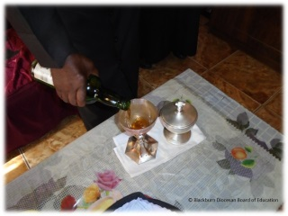 | A Christian sacrament commemorating the Last Supper by consecrating bread and wine
Holy Communion  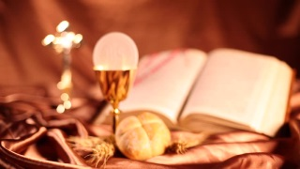 | The Eucharist, also called holy communion, the sacrament, or the Lord's supper, is a kind of religious ritual in many Christian churches.
sacrifice | A sacrifice is a loss or something you give up, usually for the sake of a better cause.
Salvation  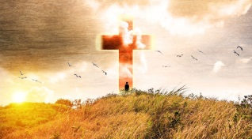 | The act of delivering from sin or saving from evil. saving someone or something from harm of from an unpleasant situation
sacrament | A Christian religious act or ceremony that is considered especially sacred.

Last Supper
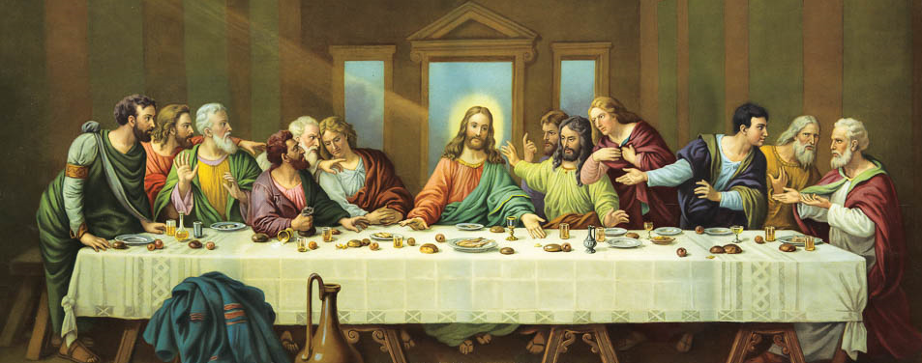
The Last Supper is the final meal that, in the Gospel accounts,
Jesus shared with his apostles in Jerusalem before his crucifixion.
The Last Supper is commemorated by Christians especially on
Maundy Thursday.

