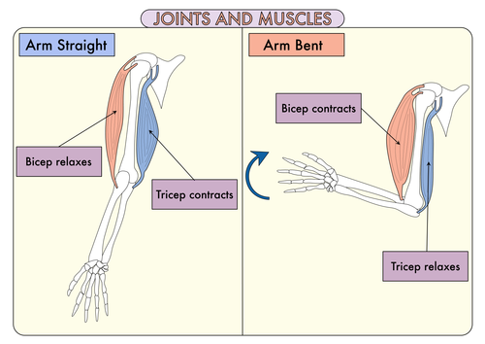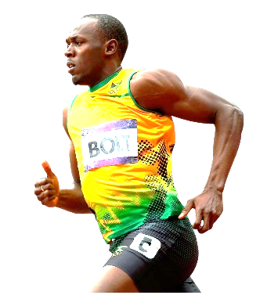

The three systems that mainly deal with human movement are the **muscular, nervous, and skeletal systems**.