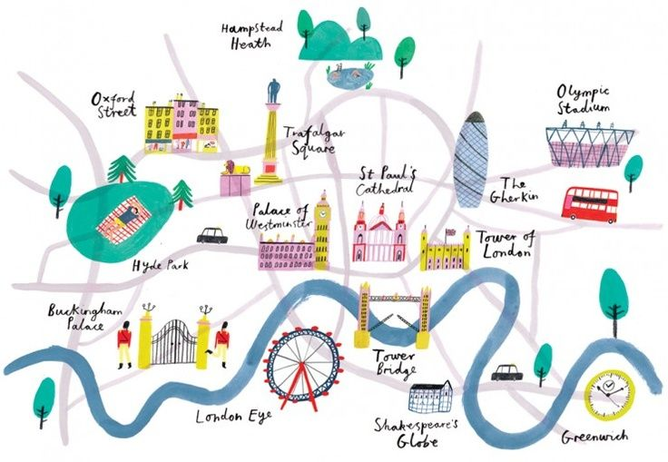
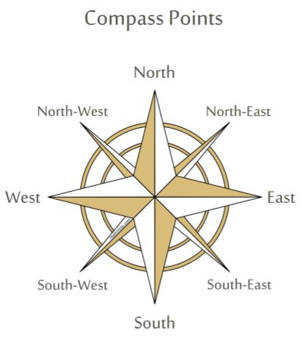
Big Ideas
Key Vocabulary
United Kingdom | Made up of England, Northern Ireland, Scotland and Wales. Sometimes known as the UK.
Map | A representation of an area of land or sea showing physical features, cities and roads.
Compass | An tool used for finding direction.
Capital City | A city where the countrys government leaders work.
Landmark | An object or feature of a town or city that has importnace or makes a place easily recognisable.
Town | A human settlment that is larger than a village but smaller than a city.
Countryside | A rural area used for farming or left in its natural condition.
Transport | A vehicle that can take or carry people or goods from one place to another.
Directions | A course along which somehing moves, lies or points.

