

**BIG PICTURE**

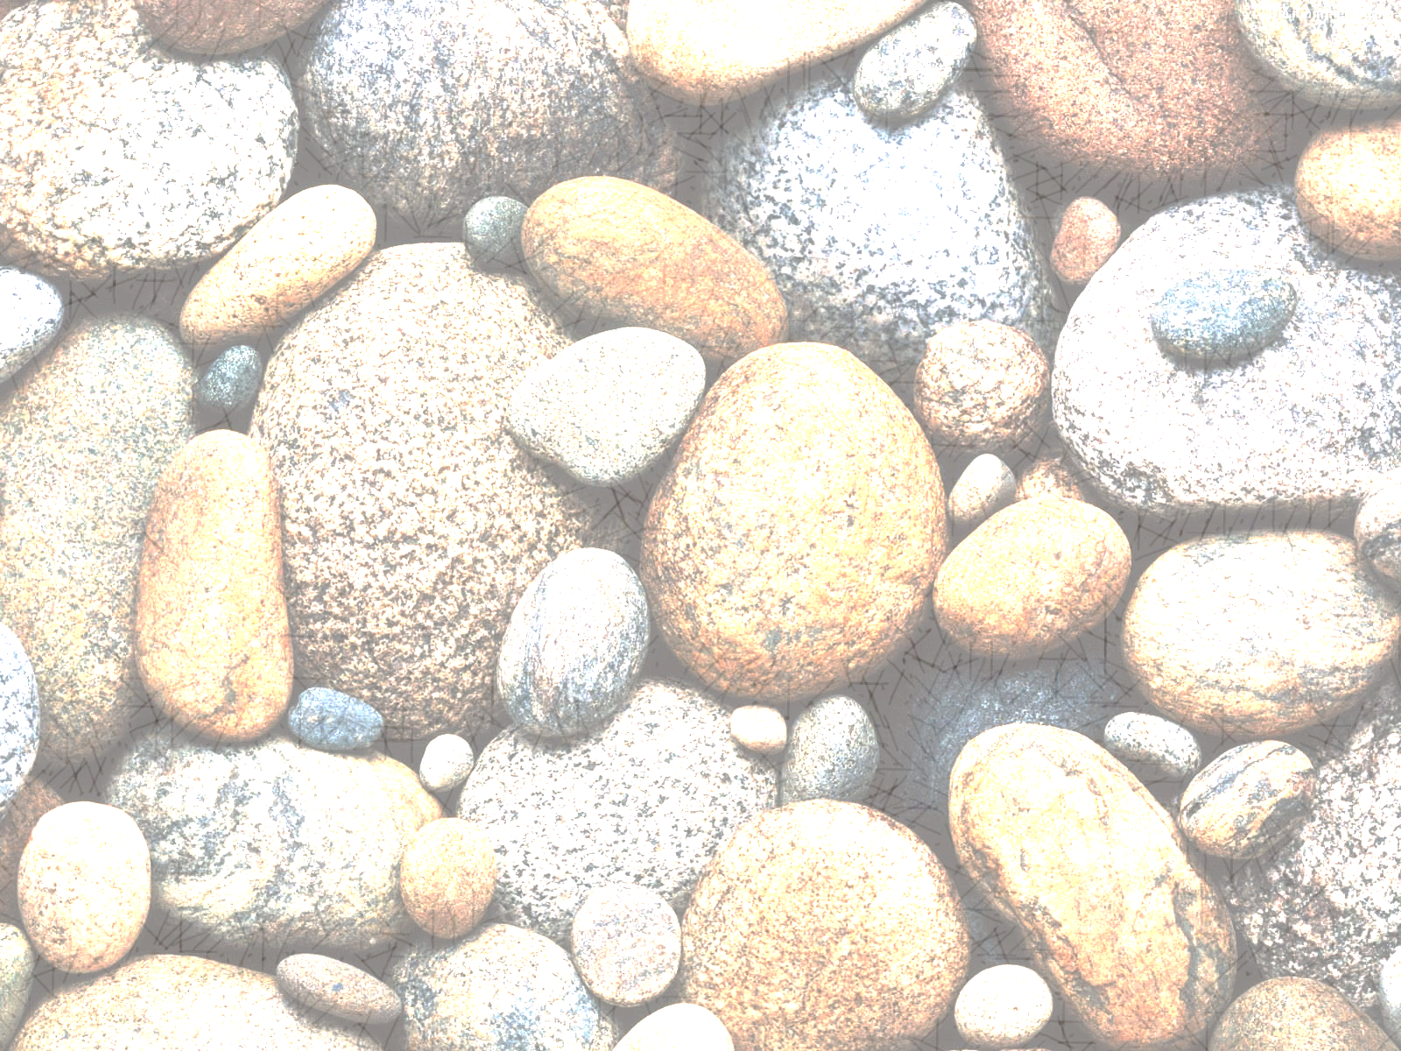 **What do rocks tell us about the way the earth was formed?**

**Questions we will investigate:**

* **How are rocks made ?**
* **Are all rocks the same ?**
* **How do we use rocks in our every day lives ?**
* **what are fossils and why are they so fascinating ?**
* **How is a fossil made ?**
* **Where does soil come from ?**

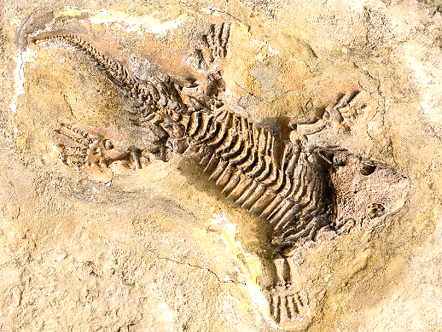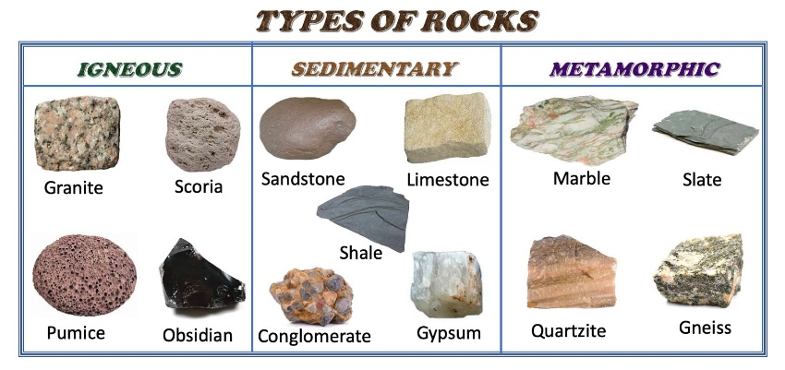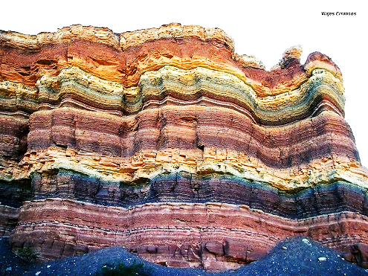

**Skills I will use:**

describing

comparing

explaining

observing

predicting

problem solving

**Vocabulary I will use:**

hard soft shiny permeable impermeable

sedimentary igneous metamorphic

erosion porous weathered layers debris

fossil properties man-made

**What do I want to find out ?**