**Romans’ Rule**

Roman laws, written around 450 BC, were called the ‘Twelve Tables’. Not following these rules was a crime. Punishments were severe to **deter** people from not following them.

Legionaries in Britain would be responsible for finding and catching suspects, **Judges** and **juries** were used to decide if someone was guilty or not guilty. People could pay to have their punishment lessened. The worst crime, **treason**, had the harshest punishment.

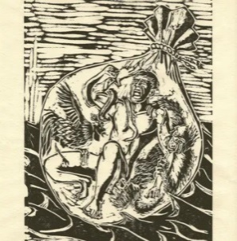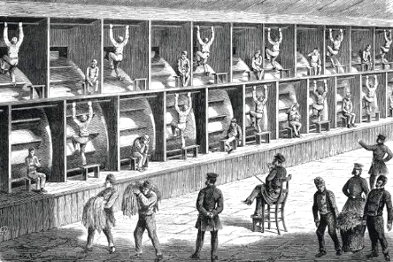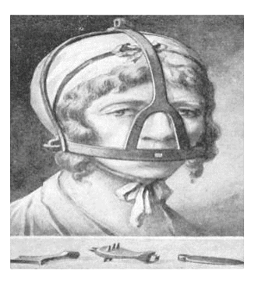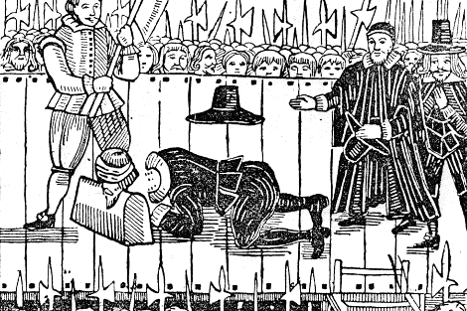

The Tudors

**wergild**

means 'blood price', was a system of fines used by the Anglo-Saxons, where, if you injured someone, the victim received money

The Victorians looked for alternative ways to hanging people for committing crimes. Many prisons were built in order to prevent people committing further crimes. Life in prison was very tough. Prisoners had to do very physically demanding tasks. These included:

* the treadwheel - using the steps on a huge wooden and iron wheel to move it
* shot drill - lifting a heavy iron cannonball
* the crank – machinery that victims turned 10,000 times a day

**Victorians Villains**

**Tudor Torture**

To **deter** people from committing crimes, the Tudors came up with even more terrifying punishments, including public **executions**. Public **humiliations** were common. The scold’s bridle was worn for gossiping; the rack used to stretch out the **victim**’s body for **treason**; and the dunking stool to find out if someone was a witch.

**Key vocabulary**

The Victorians

The Romans

The Anglo- Saxons

**43 450 1066 1485 1603 1837 1901**