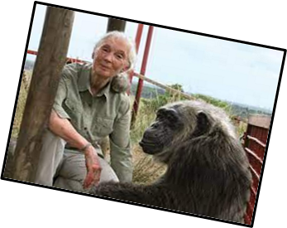
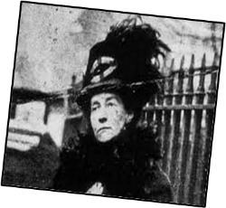
How have people helped to make the world a better place?
Big Ideas
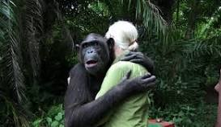
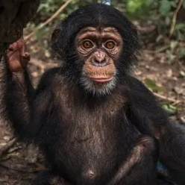

Jane Goodall was a conservationist who wanted to protect animals from cruelty and mistreatment.
She was an expert on chimpanzees and studied them for over 60 years in Tanzania.
Vocabulary | What does it mean?
Significant | Somebody or something important
Chronology | In order of time
Timeline | The order that things happened
Inspire | To look up to or be influenced by somebody
Campaign | To stand up for something important
Support | To help somebody
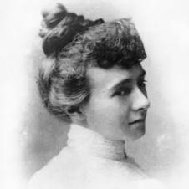
Martin Luther King was a black leader who wanted equality for all. He was American and didn’t want black people to be mistreated.
Emily Davison campaigned for women to have equal rights – she was a Suffragette.
Florence Nightengale was a nurse in the Crimean War. She cared for lots of sick soldiers. She carried a lamp. Florence improved hospital conditions.
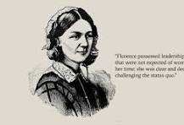

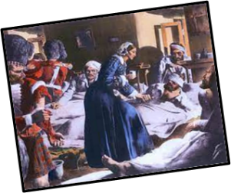

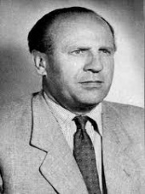
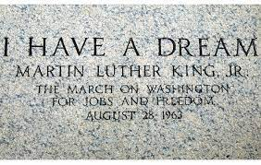
Oskar Schlinder saved the lives of thousands of Jews in World War 2 in Germany.

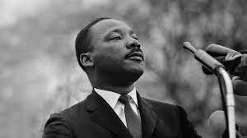

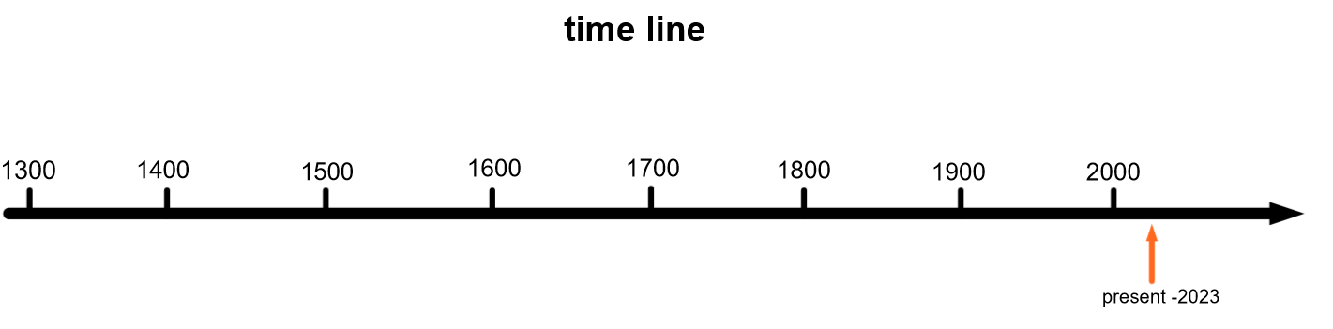

Who? | 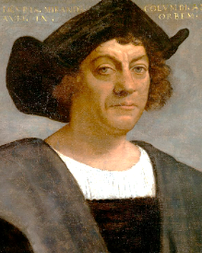  Christopher Columbus | 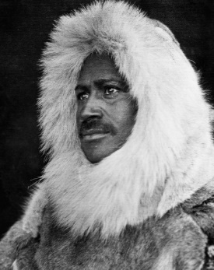  Matthew Henson | 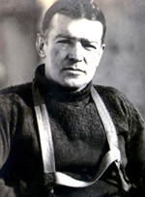  Ernest Shackleton | 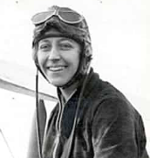  Amy Johnson | 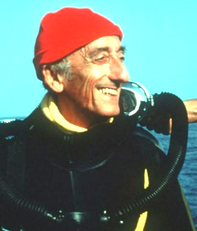  Jacques Cousteau | 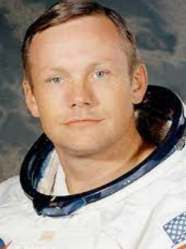  Neil Armstrong | 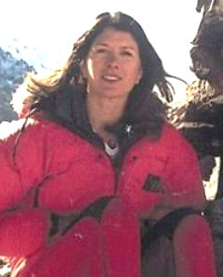  Rebecca Stephens | 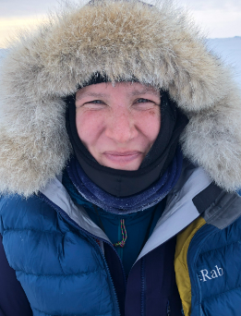  Felicity Aston
When? | 1492 | 1909 | 1914-17 | 1930 | 1940s-1980s | 1969 | 1993 | 2012
Where ? | Atlantic Ocean | Arctic | Antarctic | skies | Underwater -oceans and seas | space | Mountains | Antarctic
What ? | First European to discover the ‘Americas’ | The first person to set foot on the North Pole | Led his team to try and cross Antarctica | First woman to fly solo from London to Australia | He opened up more of the Earth's surface to humankind than any other explorer in history | First person on the moon | First woman to climb Mount Everest | First woman to cross Antarctica solo

