NASA FACT FILE

NASA is a US space agency, that stands for ‘National Aeronautics and Space Administration’. NASA was founded by Dwight D. Eisenhower on July 29, 1958, making NASA 60 years old as of 2018.

NASA’s main headquarters is based in Washington DC, in the United States of America (USA). NASA also has other operations in other parts of the country. NASA is backed by the US government and as of 2018 has an annual budget of over $20 billion, and as of 2018, NASA employs over 17 thousand people.

There have been many missions that NASA have undertaken since the organization was founded, with the most famous mission being the moon landings.

TIMELINE
- 1961 – Freedom 7. 1st space launch, launching the 1st American to space. Alan Shepard.
- 1968 – Apollo 8. Apollo 8 spacecraft had a mission to orbit the moon.
- 1969 – Apollo 11. 1st and very famous moon landing mission.
- 1969 – 1972 – 5 more successful manned moon landings.
- 1970 – Apollo 13. With the spacecraft exploding, NASA launched a rescue mission.
- 1972 – Pioneer 10. Unmanned mission to the solar system.
- 1972 – Space Shuttle. NASA’s first launch of the Space Shuttle.
- 1977 – Voyager Mission. In 1977 NASA launched the Voyager missions.
- 1986 – Challenger Launch. 73 seconds from launch the shuttle exploded killing all the crew.
- 1990 – Voyager Pale Blue Dot Photo. Famous photo taken at the request of Carl Sagan.
- 1990 – Hubble Telescope. Launched from ‘Discovery’ to photograph the stars in detail.
- 1996 – Pathfinder Mission. Mission launched to Mars to gather data of the planets surface.
- 1998 – International Space Station. Joint international venture space station lunched.
- 2003 – Mars rovers Spirit & Opportunity. Launched to Mars in the search for water.
- 2012 – Mars Curiosity Rover. Launched to explore possible Life on Mars.

Below is a picture of the first moon landing in 1969
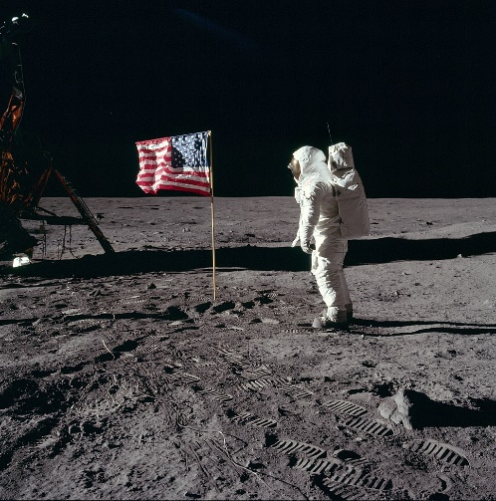

With continued budget and backing from the US government, NASA is continuing it’s great work in space exploration. There are many future planned missions and great research and work ahead.

From the year 2020, there are future planned missions to near Asteroids and other solar system planets.

There has been no date yet confirmed for a manned mission to Mars.

QUICK FACTS:
1. NASA pays people to lay in bed for long periods of time to study the effects of prolonged weightlessness.
2. The man who invented the super soaker water gun was a NASA scientist.
3. There are 2 satellites named ‘Tom & Jerry’ that have been launched by NASA that follow each other in orbit around the Earth.
4. The date of the 1st moon landing was July 16, 1969.
5. The crew of the 1st moon landing was Neil Armstrong, Buzz Aldrin & Michael Collins.

