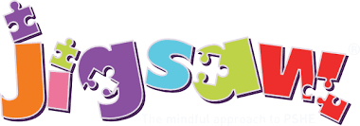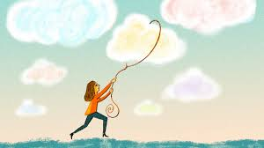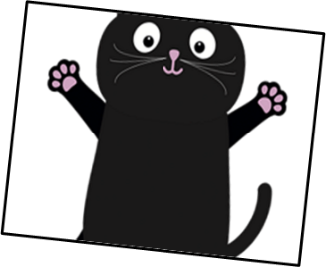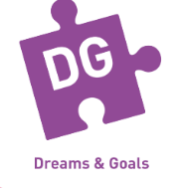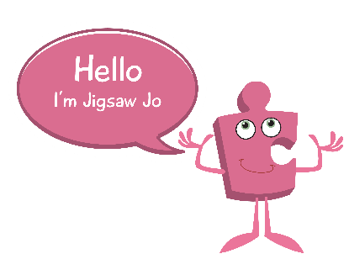

Skills we will use on our learning journey:

Listening

Sharing

Reflecting

Explaining

Understanding

Vocabulary we will use on our

learning journey:

challenge

achieve

resilience

dream

proud

**Questions we will investigate on**

**our learning journey:**

* Can I stay motivated when things go wrong?
* Can I keep trying when things are hard?
* Can I work well in a group?
* Do I have a positive attitude?
* Do I help others to achieve their goals?
* Am I working towards achieving my dreams?

Question I would like to ask:

**Dreams and Goals**

**BIG PICTURE**