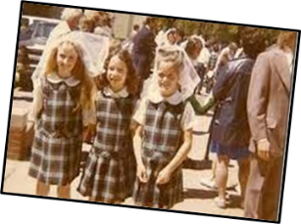
What has changed since my grandparents were young?

Big Ideas
Our grandparents' clothes were made in natural materials like wool and cotton. Sometimes their clothes were made at home or in the local dressmakers. They were expensive to buy or make.
Clothes were often passed down from older brothers or sisters or cousins. Often, their mammies fixed the holes and tears that playing and working made in trousers and skirts.

Vocabulary | What does it mean?
New | Something that you may use or have now
A long time ago | Not happening now
Old | Someone who is not young
Before | Something that happened earlier
After | Something that happened later
Grandparents | My parents Mum and Dad
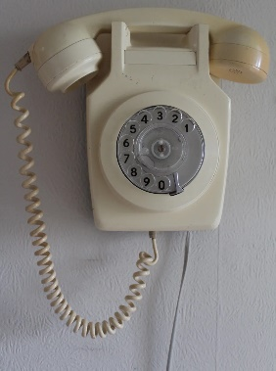
What children's show first aired in 1969?

Sesame Street, American educational television series for children. It debuted in 1969 on the National Educational Television network, an entity that became the Public Broadcasting Service (PBS) in 1970. 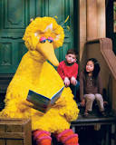

What children's TV show first aired in 1972?
Rainbow
Rainbow (1972–1992)
Children's puppet programme featuring music and stories.

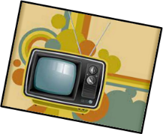

Mobile phones were not invented.
Phones looked very different.
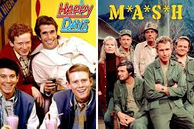

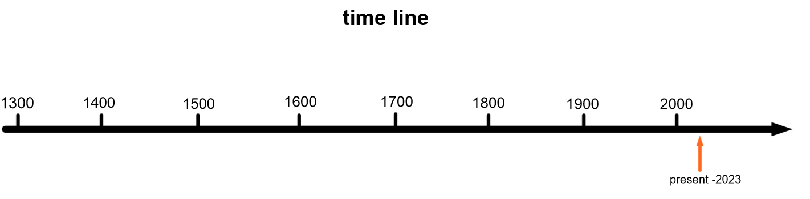

Who? | 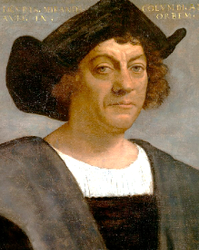  Christopher Columbus | 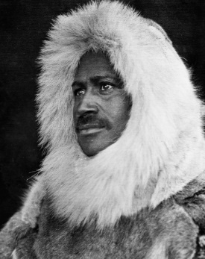  Matthew Henson | 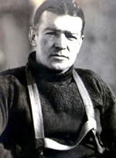  Ernest Shackleton | 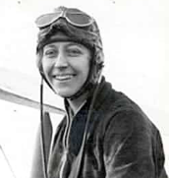  Amy Johnson | 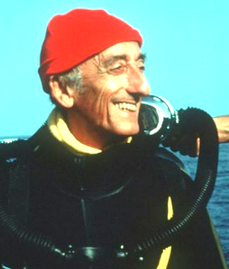  Jacques Cousteau | 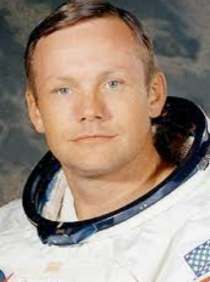  Neil Armstrong | 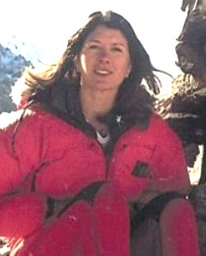  Rebecca Stephens | 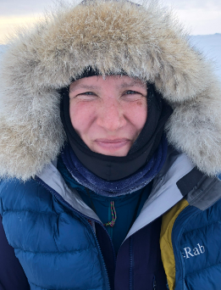  Felicity Aston
When? | 1492 | 1909 | 1914-17 | 1930 | 1940s-1980s | 1969 | 1993 | 2012
Where ? | Atlantic Ocean | Arctic | Antarctic | skies | Underwater -oceans and seas | space | Mountains | Antarctic
What ? | First European to discover the ‘Americas’ | The first person to set foot on the North Pole | Led his team to try and cross Antarctica | First woman to fly solo from London to Australia | He opened up more of the Earth's surface to humankind than any other explorer in history | First person on the moon | First woman to climb Mount Everest | First woman to cross Antarctica solo

