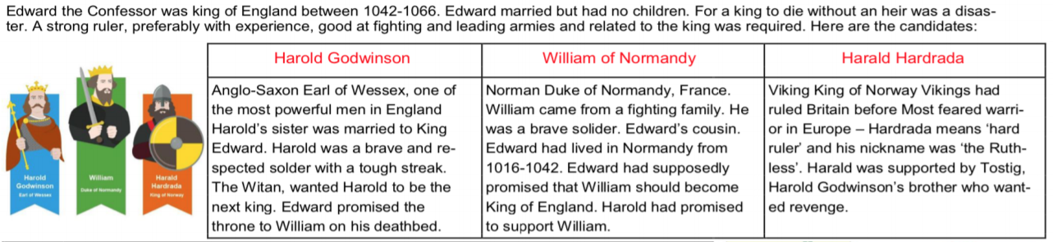

**VOCABULARY**

**baron**- high ranking nobles ruled large areas of land called fiefs. They reported directly to the king and were very powerful.  
**peasant** – a person of low social status who works on the land ( farmers)

**fief** – land given out by the monarch

**vassal**- the person getting the land

motte

bailey

keep

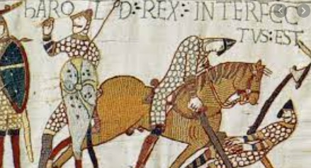

What happens when there is no heir and 3 people all want the job ?

Diagram to show how the feudal system worked.

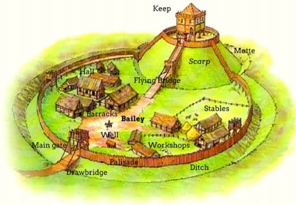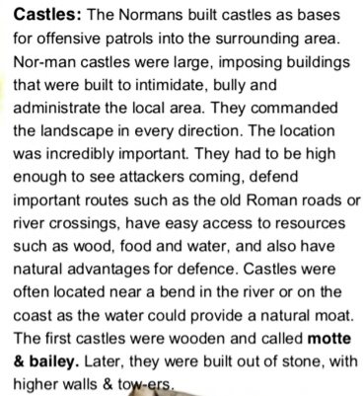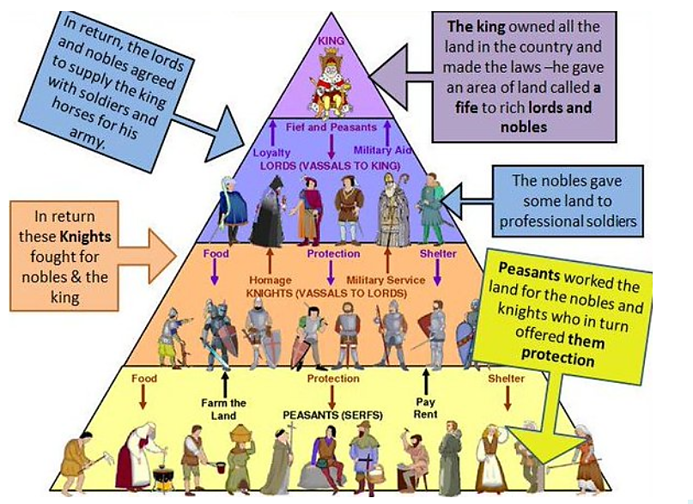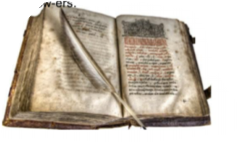

The Bayeux Tapestry is a 70 metre long embroidered cloth which tells the story of the events leading up to the Battle of Hastings in 1066, and the battle itself.

**The Doomsday Book** -a record to tell William how much property and land was owned by people of England to allow him to tax them more.

**heir**- a person who has a legal claim to property, a title , the throne

**conquest**- to take control by force

**defence**- to protect or guard

**elite**- people of the highest class

**What happened in the Battle of Hastings?**

The bloody **battle** took place on the 14 October 1066. It was fought between William of Normandy and King Harold – the King of England – and it was the English throne that was at stake. The Normans were victorious, beating the Anglo-Saxons (the English to you and me). William of Normandy was crowned king on Christmas day. He was William I, also known as William the Conqueror