Science Big Picture:
What are objects around our school made of? 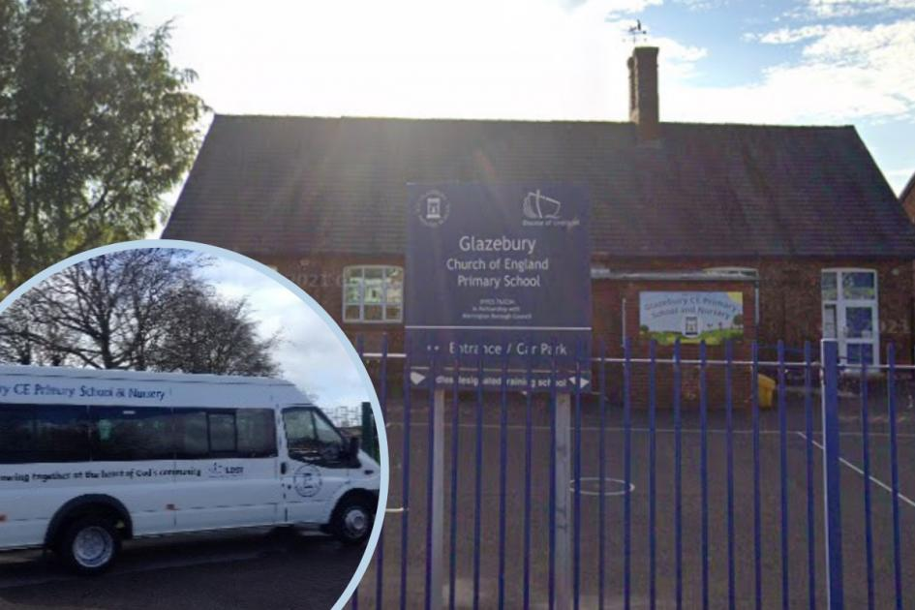 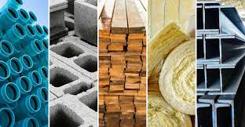 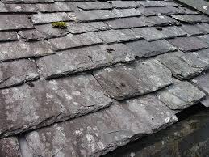
Questions I would like to explore:
- How can we classify toys?
- What are the main materials school is made from?
- What are the main reasons for choosing materials for different parts of our school?
- What other items can I find made of metal, glass, plastic and wood?
- Can I make a toy using a range of materials?
- How can I explain why I have chosen materials for my toy?
- How can I present to the class information about a material?
Key vocabulary I will use:
materials wood metal glass rock brick paper
cardboard squashing stretching waterproof
bending twisting solid
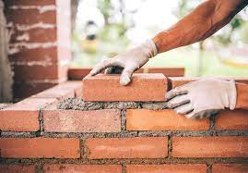
Question I would like to ask?
Skills I will use and learn:
- Observation
- Comparing.
- Classifying
- Recording
- Discussing
- Reflecting and evaluating

