|  |
| --- |
| * **When was the Stone Age?** |
| * **If it happened so long ago in the past, how do we know about it ?** |
| * **Were there any changes in the way people got their food ?** |
| * **What were peoples ‘ homes like during this period of time ?** |
| * **What significant discoveries occurred in the Iron Age ?**   How people hunted animals for food in the Stone Age — Steemit |

How did Britain change from the beginning of the Stone Age to the end of the Iron Age ?

Big Picture

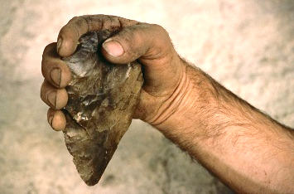

**Vocabulary**

archaeologist

artefacts

settlement

hunter-gatherer

nomadic

iron fort

Skara Brae

wattle and daub

Palaeolithic

Mesolithic

Neolithic

artefact

Britons

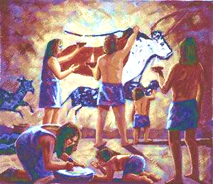

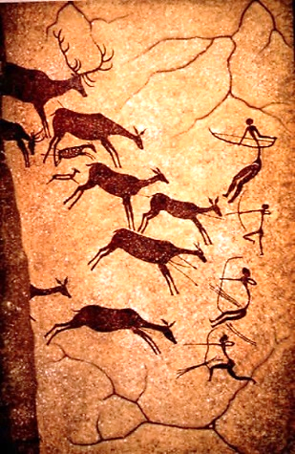

Question I would like to ask :

