|  |  |
| --- | --- |
| **Key Words** | |
| Harvest | When farmers collect the crops that they have grown |
| Festival | When people come together to celebrate something |
| Gifts from God | Something nice sent or believed to be given by God |
| Sukkot | A festival to remember the Exodus |
| Celebrate | To do something enjoyable |
| Jewish | A person who believes in the Jewish faith |

**How can we help those who don’t have a good harvest?**

**BIG IDEAS**

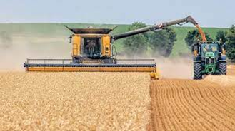 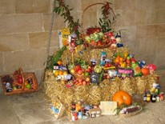

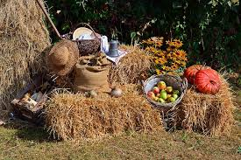 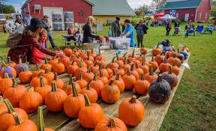

Foods that we eat come from all around the world.

Not every country in the world has a good harvest every year.

Some charities, like The Trussell Trust, help people who don’t have enough to eat at Harvest time.

The festival of Sukkot is celebrated at the same time as Harvest. This is a time to remember the Exodus when Moses led the people out of Egypt to freedom. They lived in shelter called Sukkahs.

