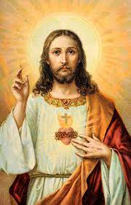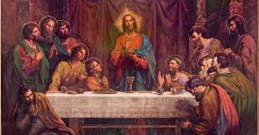

Key Aims

* To enjoy the stories of Jesus’ miracles
* To know that Jesus welcomed everybody
* To know Jesus was extraordinary

Question I would like to ask:

Vocabulary we will use on our

learning journey:

trust

Bible

Old Testament

New Testament

Holy

Gospel

Word of God

miracle

faith

behaviour

**Questions we will investigate on**

**our learning journey:**

* What is a miracle?
* Why did Jesus welcome everybody?
* How might I have felt to meet Jesus?
* What did Jesus want us to learn from his behaviour?
* What do the stories reveal about Jesus?

**Why was Jesus a friend to everyone?**

?

**BIG PICTURE**