Key vocabulary | Definition
Amphibians | Amphibians are cold-blooded vertebrate animal (frogs, toads, newts, salamanders, and caecilians) characterised by their smooth, slimy skin and their lack of scales, feathers or hair.
Arachnid | Arachnids are a class of animals that includes spiders, scorpions, mites, and ticks. Most arachnids have a segmented body divided into two regions, with the front part bearing four pairs of legs, but no antennae.
Crustacean | Crustaceans usually have a hard covering, or exoskeleton, and two pairs of antennas, or feelers. All crustaceans are arthropods.
Environment | The environment includes everything living and everything nonliving. ... People, animals, plants, and all other living things rely on the nonliving parts of the environment to survive.
Mammals | A mammal is an animal that breathes air, has a backbone, and grows hair at some point during its life. In addition, all female mammals have glands that can produce milk
Reptiles | Reptiles are animals that are cold-blooded. Most reptiles lay eggs and their skin is covered with hard, dry scales.

Life Cycle
All animals, including humans, are born, they get older and bigger and some will go on to have children. In the end, all animals die. We call this a life cycle.
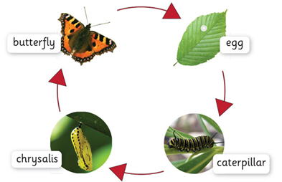
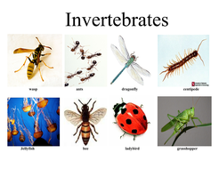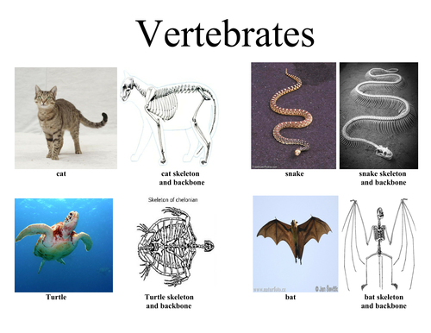
Invertebrates are animals that don't have a backbone. Some have soft bodies, like worms, slugs and jellyfish. Other invertebrates, like insects, spiders and crustaceans, have a hard outer casing called an exoskeleton. This protects their body a bit like a suit of armour. Vertebrates have a backbone inside their body.
Fungus Mollusc
