How and why do Christians read the Bible?

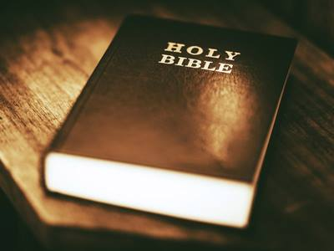 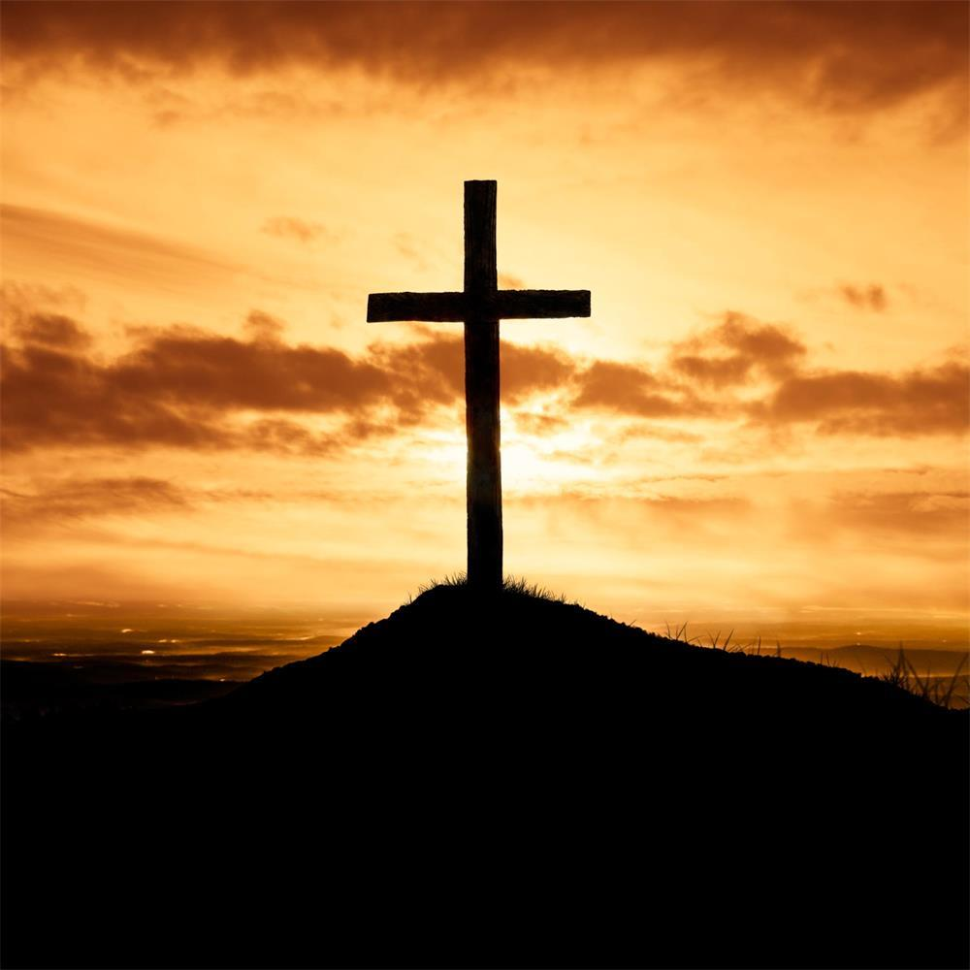

Vocabulary we will use:

Old Testament New Testament Gospel

Word of God Translation

**Questions we will explore:**

* How and why is the Bible used?
* Do you need a Bible to be a Christian?
* Why is the Bible holy?
* Why is the Bible a best seller?
* Why are there so many versions of the Bible?

Skills I will use:

* Observation
* Research
* Reflection and evaluation
* Use of IT
* Art
* Presentation via powerpoint

Questions I would like to ask...