BIG PICTURE
Why do we have castles?
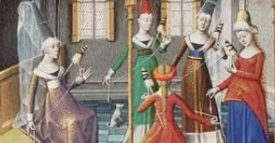
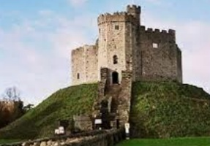
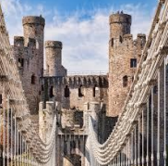
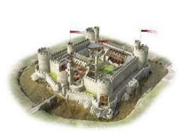
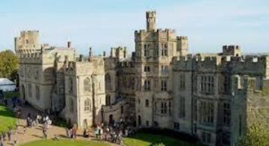
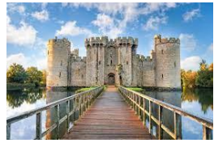
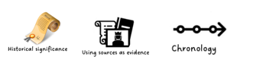
Question I would like to ask:

________________________________
________________________________

Skills we will use on our learning journey:
reading
sequencing
reasoning
research
explaining

Vocabulary we will use on our
learning journey:
moat
drawbridge
knight
turret
keep
portcullis
Questions we will investigate on
our learning journey:
- What is a castle?
- How were castles used to protect people and to give them security?
- Why is there a castle not too far away from where you live?
- What are the special features of a castle?
- Why do castles feature in many of our best-loved stories?

