Big Picture

**How do the seasons impact on what we do?**

**Questions we will explore:**

* What is the position of our planet within our solar system?
* How does the position of the earth determine our seasons?
* Can we name and describe the four seasons?
* What tools are used to gather information about the weather?
* Can we create a calendar identifying the seasons and suitable activities?
* Do we understand what a cold area of the world is like and how their seasons are different?
* Do we understand what a hot area of the world is like and how their seasons are different?
* I know what clouds are made from and that there are different types of cloud?

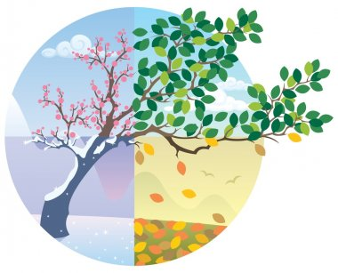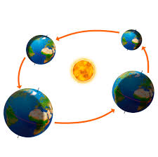

**Questions I would like to ask…**

**Vocabulary I will use….**

* Weather
* Seasons
* Orbit
* Position
* Temperature
* Equator
* Solar system

**Skills I will use….**

* Observation
* Research
* Discussion
* Gathering and interpreting data
* Hypothesising
* Predicting
* Investigating