**How do some solids , liquids and gases change state ?**

**Vocabulary we will use:**

states of matter

solids

liquids

gases

water vapour

melt

freeze

condense condensation

evaporate evaporation

precipitation

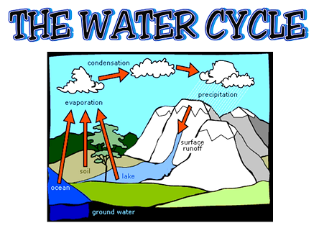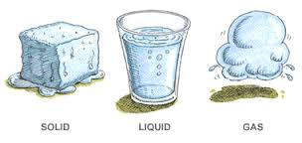

Question I would like to ask:

**Skills we will use:**

discuss

read

observe

record

compare

investigate

measure

* How can we classify solids, liquids and gases?
* What do we mean by freezing and melting?
* How can you separate sand, salt and water?
* What is the water cycle ?