Big Picture
Why was Joseph special?
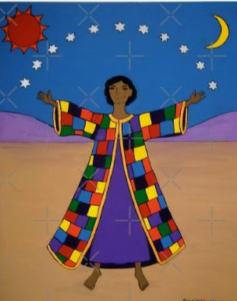
Questions we will explore:

- Can we recall the story of Joseph and his technicolour coat?

- How did Joseph and his brothers feel throughout the story?

- How do we know God was with Joseph throughout the story?

- Can we describe the lessons we can learn from this story?

- Can we make our own technicoloured tie dye top like Joseph?
Questions I would like to ask…

Vocabulary I will use….
- Joseph
- Jacob
- Brothers
- Dreams
- Technicolour coat
- Egypt
- Forgiveness

Skills I will use….
- Sharing Bible stories
- Observation
- Discussion
- Reflection and evaluation
- Prayer
- Design and creation
- Empathy and comparison

