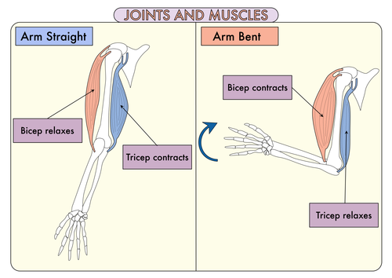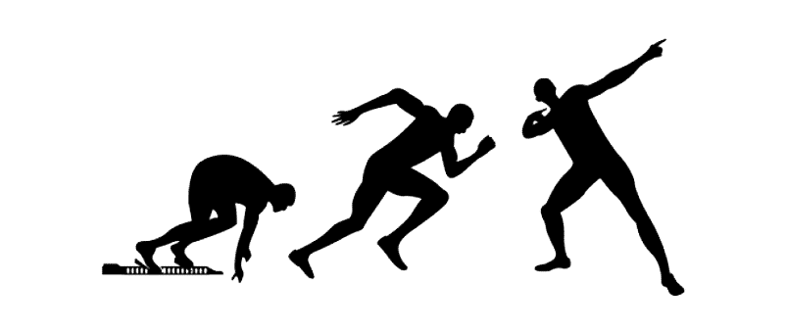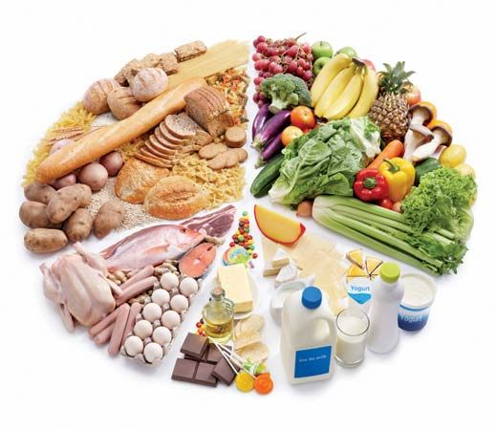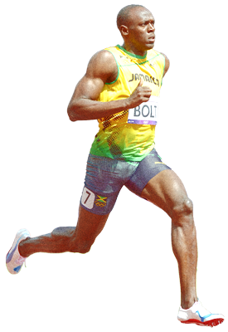

Vocabulary we will use:

skeleton

muscles

nerves

tendons

ligaments

joints

nutrients

balanced diet

protein

carbohydrates

fats

fibre

vitamins

minerals

Question I would like to ask:

***How can Usain Bolt move so quickly ?***

**BIG PICTURE**

* How long does it take for us to run 100 metres ?
* How do our bodies move ?
* Why is food important in keeping our bodies moving and healthy ?

skills we will use:

read

discuss

compare

observe

record

research

create