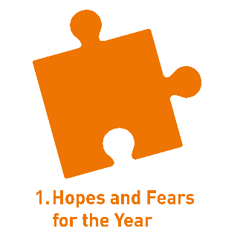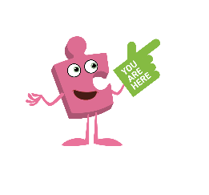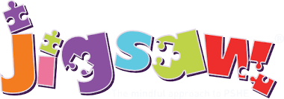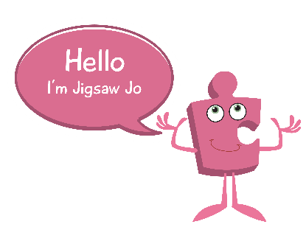 

Skills we will use on our learning journey:

Listening

Sharing

Reflecting

Explaining

Understanding

Question I would like to ask:

**Questions we will investigate on**

**our learning journey:**

* Do I agree with the Jigsaw Learning Charter?
* What are my hopes and fears for this school year?
* Do I feel like I belong to my class?
* Can I listen to other people?
* Can I help to make my class a safe and fair place?
* Can I cooperate with other people?

**Being me in my world**

Vocabulary we will use on our

learning journey:

worries

hopes

fears

belonging

rights

responsibilities

safe

**BIG PICTURE**