Why?
Why do people in the nativity story travel to Bethlehem?
BIG IDEAS
Key Words
Saviour | A person who rescues you from harm
Messiah | Someone sent by God
Christ | A saviour sent to deliver people from sin
Bethlehem | An ancient town in the Middle East
Mary and Joseph | Jesus’ parents.
Shepherds | People who care for sheep
Star | A bright light in the star that guided people to Jesus when he was born.
Wise men | Trusted people who visited Jesus
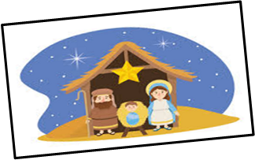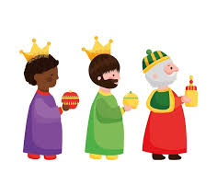
Bethlehem is an ancient town in the Middle East which is important to Christians as they believe this is where Jesus was born.

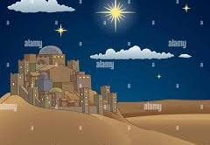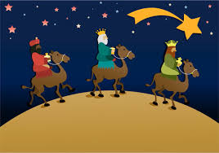
The nativity story is about the birth of Jesus Christ on Christmas day, when his mother Mary gave birth in a stable.

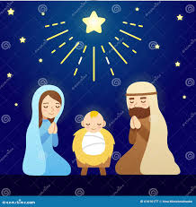
In the sky, far away in the East, three wise men saw a bright star. They knew this was a sign that a new king has been born and they followed the star to see Jesus.
