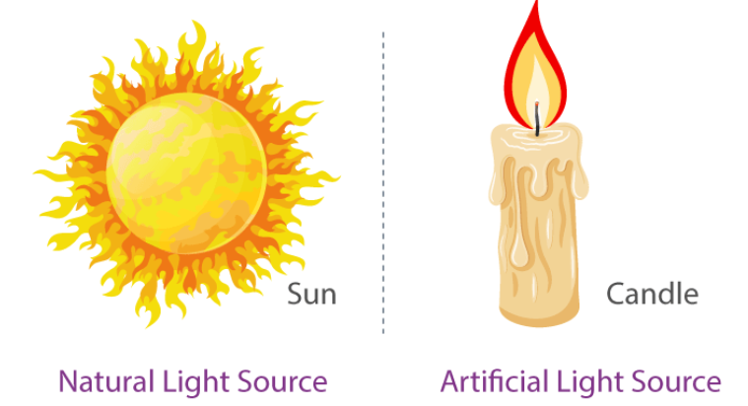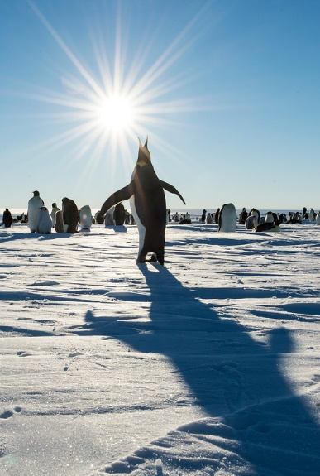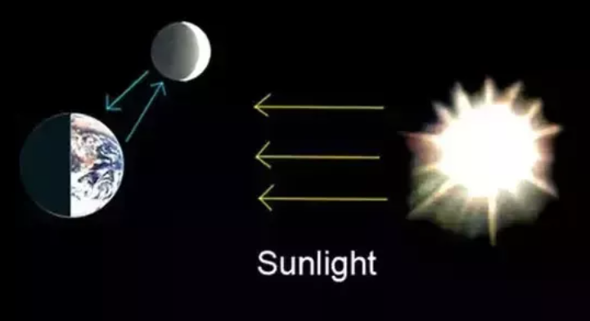

Natural light sources

**Question I would like to ask :**

**Vocabulary we will use**

light source

natural

artificial

reflect

opaque

transparent

translucent

**Skills we will use**

discuss

read

investigate

observe

share

sort

record

explain

reflect

**How could you throw your shadow ?**

**Questions we will investigate :**

* What is light and where does it come from ?
* How can you explain the relationship between the sun and the moon ? ( in terms of light )
* How is a shadow formed ?
* Can a shadow ‘ grow ‘ ?

**BIG PICTURE**