**BIG PICTURE**

The Bible – why is it such a special book?

**Questions we will investigate on**

**our learning journey:**

* Why is the Bible such a special book?
* Why do Christians believe that the Bible is a holy book?
* Which Bible stories do you enjoy and why are they important?
* Who uses the Bible? Why?
* The Bible is in two parts which are different. Why and how are they different?
* Why are Holy Books so important to people of faith?

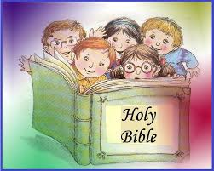

Skills I will use:

Comparing Reading Reasoning Listening Discussing Reflecting

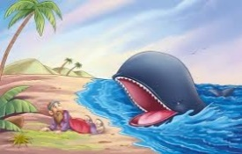

Vocabulary we will use on our learning journey:

Bible Old Testament Holy New Testament Gospel Word of God

Mary Jones Dead Sea Scrolls

Question I would like to ask:

______________________________­­­__

______________________________­­­__

______________­­­__

