Big Picture
Why would a dinosaur NOT make a good pet?
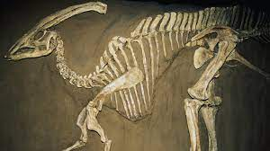
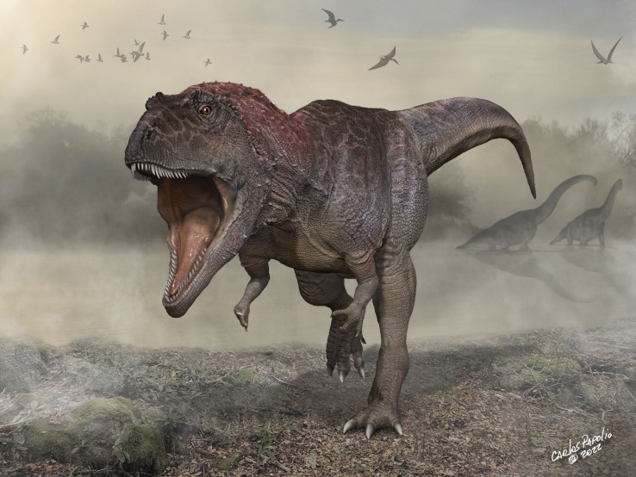
Questions we will explore:

- Can you sort animals into their groups and describe their key features?

- Can you create a timeline for the age of the dinosaurs?

- Can you explain the differences between a carnivore, herbivore and omnivore?

- What is a fossil and what information can we gather from them?

- Who is Mary Anning and what is she famous for?

Questions I would like to ask…

Vocabulary I will use….
- Jurassic, Triassic and Cretaceous periods
- Herbivore, Carnivore and omnivore.
- Fossil
- Features
- Investigate

Skills I will use….
- Research
- Observation
- Explore artifacts
- Reflection and evaluation
- Sorting
- Investigating
- Empathy and comparison

