**Jesus the teacher**

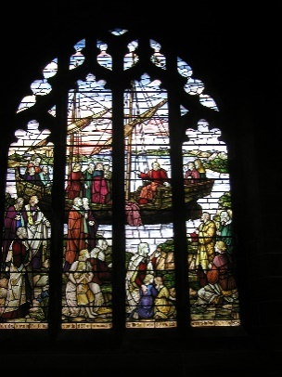

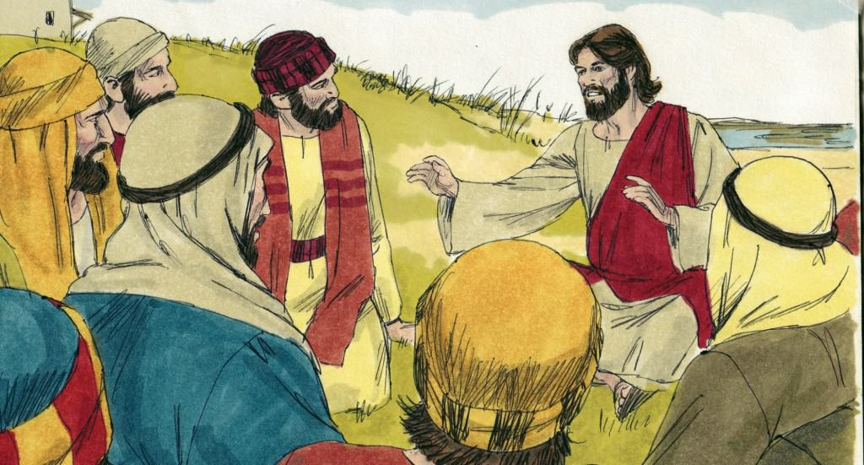

*Vocabulary we will use:*

Parable

Kingdom of God Imagery

**Questions we will explore:**

* Why did Jesus tell this story?
* What can we learn from this story?
* How does this story help us to understand Christian beliefs?
* How does this story impact on the lives of believers?

*Value:*

* Wisdom

*Skills I will use:*

* Reflect
* Apply
* Synthesise
* Analyse

Questions I would like to ask...