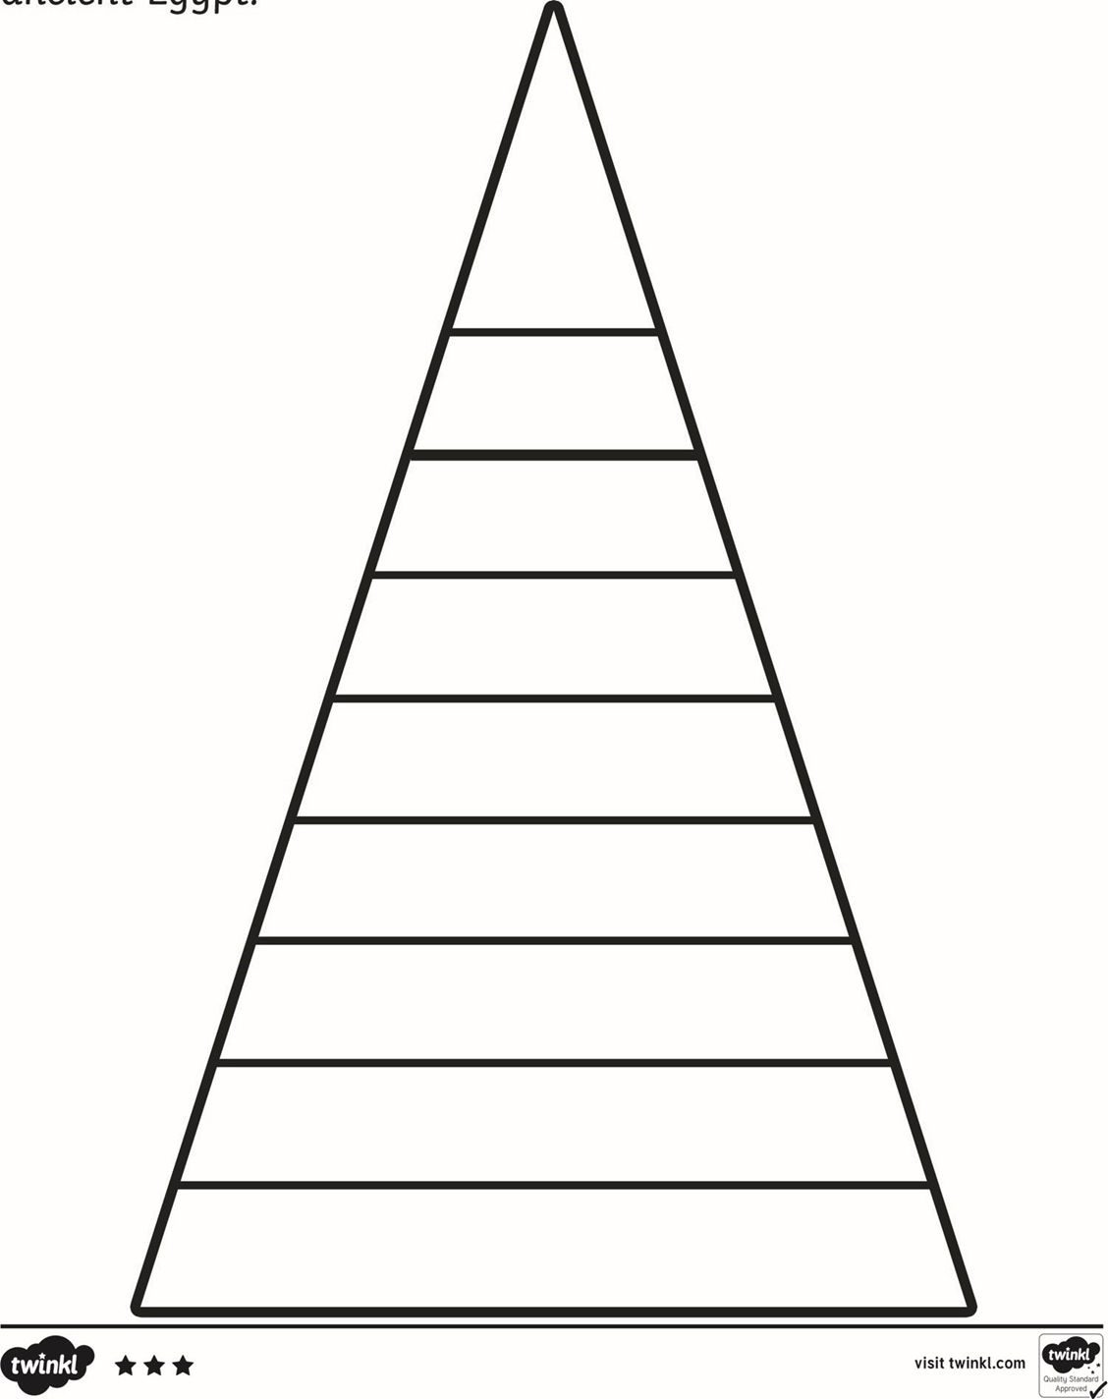

Wednesday, 20th January, 2021

LO. To label in order importance.

**Word Bank**

Craftsmen

Nobles

Pharaohs

Soldiers

Slaves

Farmers

Viziers

Priests

Scribes

Wednesday, 20th January, 2021

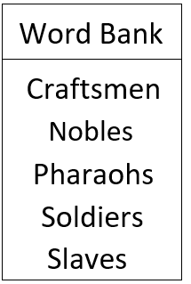LO. To label in order of importance.

Farmers

Scribes

Viziers

Priests