|  |  |
| --- | --- |
| Key vocabulary | definition |
|  |  |
|  |  |
|  |  |
|  |  |
|  |  |

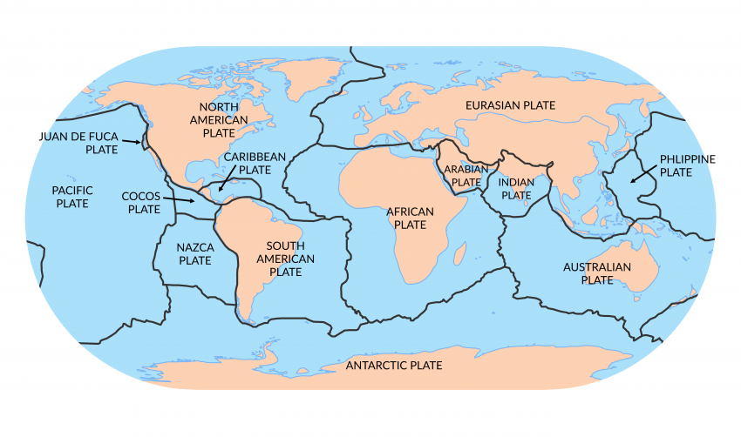

Why are mountains MIGHTY ? BIG IDEAS

**Our prior knowledge** – explorers are very skilled and brave people who go to dangerous and extreme places on Earth ( Felicity Aston and Matthew Henson) Y1

Erosion is a process which wears away rocks and riverbeds to form valleys, waterfalls and meanders Y3

