**BIG PICTURE**

**Why do we have castles?**

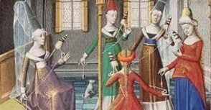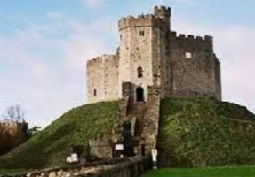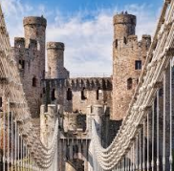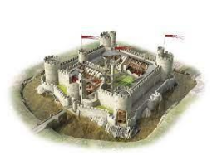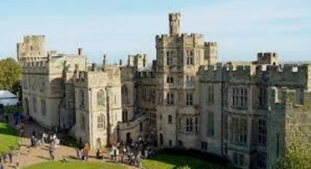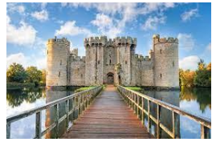

Question I would like to ask:

______________________________­­­__

______________________________­­­__

Skills we will use on our learning journey:

reading

sequencing

reasoning

research

explaining

Vocabulary we will use on our

learning journey:

moat

drawbridge

knight

turret

keep

portcullis

**Questions we will investigate on**

**our learning journey:**

* What is a castle?
* How were castles used to protect people and to give them security?
* Why is there a castle not too far away from where you live?
* What are the special features of a castle?
* Why do castles feature in many of our best-loved stories?