**Why?**

The Bible – why is it such a special book?

**BIG IDEAS**

|  |  |
| --- | --- |
| **Key Words** | |
| Bible | A religious text from Christianity. |
| Old Testament | The first part of the Bible |
| New Testament | The part of the Bible that was written after Jesus lived on Earth. |
| Holy | To be pure and perfect |
| Gospel | Means ‘good news’ and linked to Jesus |
| Word of God | The words that God has said |
| Mary Jones | A young Welsh girl who travelled far to get a copy of the Welsh Bible |
| Dead Sea Scrolls | Ancient Jewish manuscripts |

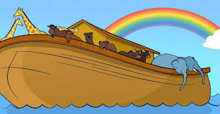 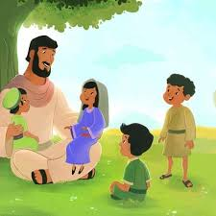

The Bible was written around 1200 bce. It was written in Hebrew. It contains 24 books and is split into 3 sections; The Law, The Prophets and The Writings.

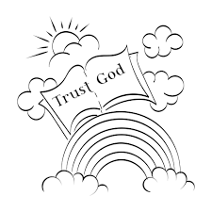 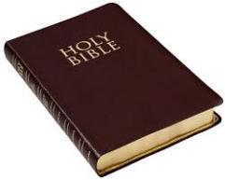

The Bible tells many stories and every story helps us to get to know what God is like, what we are like and how God wants us to live.

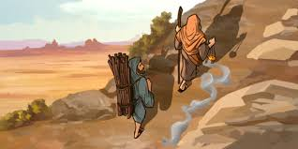 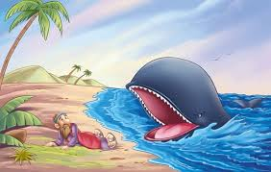

Some of the Bible stories for children include ‘God created Adam and Eve,’ ‘Noah and the Ark,’ ‘David and Goliath,’ ‘Jonah and the whale’ and ‘Daniel in the lion’s den.’

