**Religious Education:**

**How does having faith affect a believer’s lifestyle?**

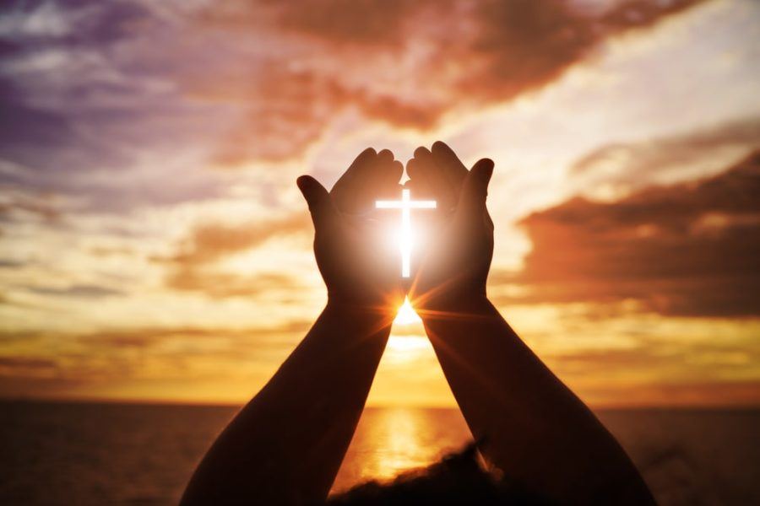

**Questions we will explore…**

* What is faith?
* What does it mean for a person to have faith?
* What does it mean to be a person of faith?
* What motivates people of faith?
* How does having faith affect people’s lives?
* In what ways have people of Christian faith built God’s kingdom on earth?
* In what ways do people of Christian faith build God’s kingdom on earth today?

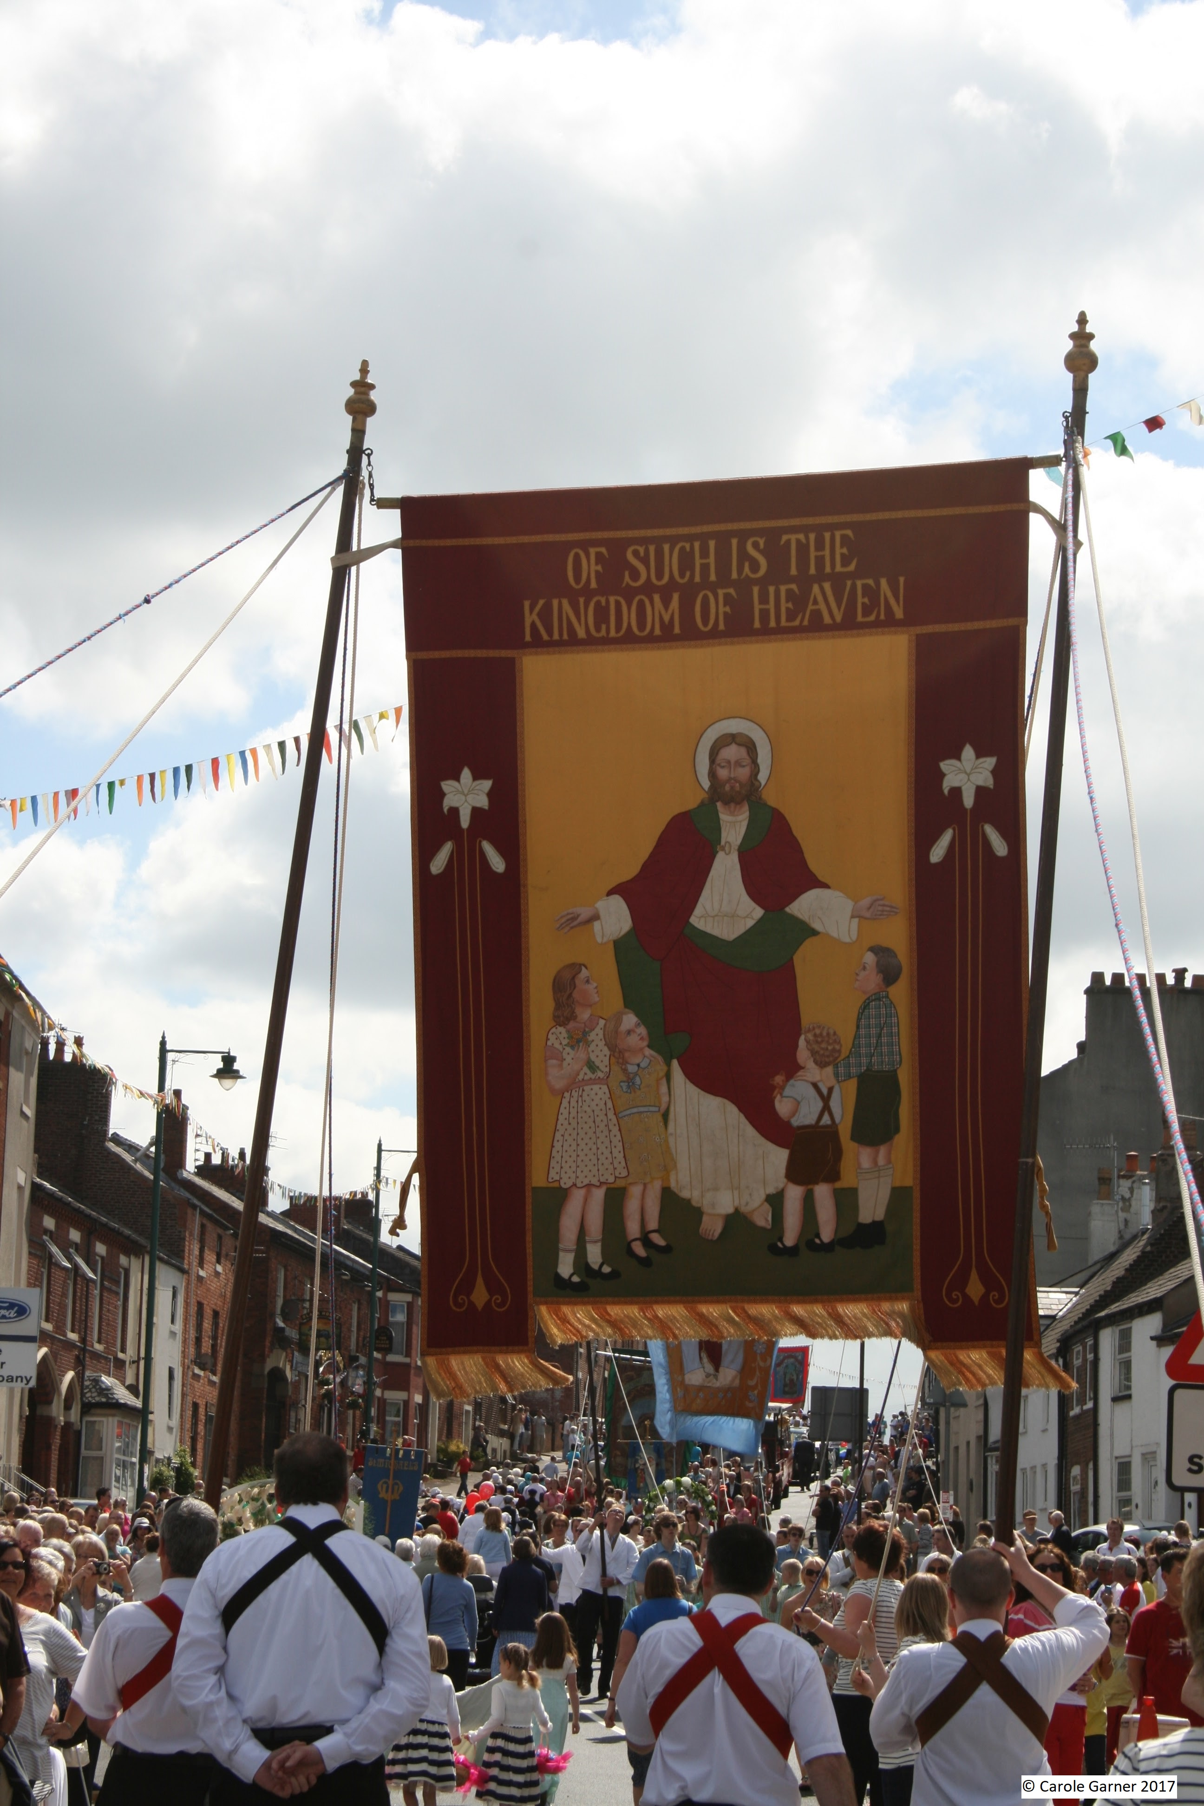

**Faith in action**

**Skills**

Interpret

Evaluate

Apply

Enquire

**Values**

Faith

Courage

Compassion

Perseverance

Service

**Vocabulary:**

faith

ministry,

mission,

Kingdom of God

vocation.

**Questions I would like to ask?**