**Religious Education:**

****Ideas about God.**

**Questions we will explore…**

* What words would you use to describe God?
* What is the nature and character of God? What images do you have of God?
* How is it possible for God to be visible and yet invisible?
* Where is God? How old is God?
* What is God’s name? What makes God happy? What makes God sad?
* What does God do all day?
* Does God really know everything? How do you know?

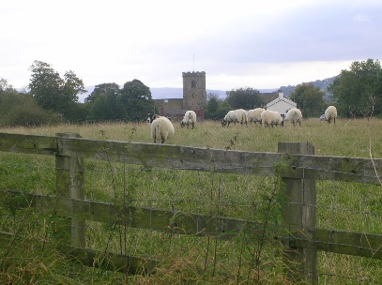

**Vocabulary:**

God

Father

Son and Holy Spirit

Trinity

Celtic

**Values**

Faith

Wisdom

Respect

Reverence

**Skills**

Analyse  
Investigate  
Apply

Reflect

**Questions I would like to ask?**