**Will we ever send another human to space?**

**Questions we will explore:**

* Could we describe the Earth and the Sun as space cousins?
* If the Earth and Sun are cousins, is the Moon a young nephew?
* Can you explain why we have day and night?
* How can we appreciate the distances between and the sizes of the Sun, Earth and Moon?
* What can we learn about the solar system and the other planets in it?
* Who was Neil Armstrong and what would you ask him if you met him?
* How could you create a moon surface and create a moon buggy?

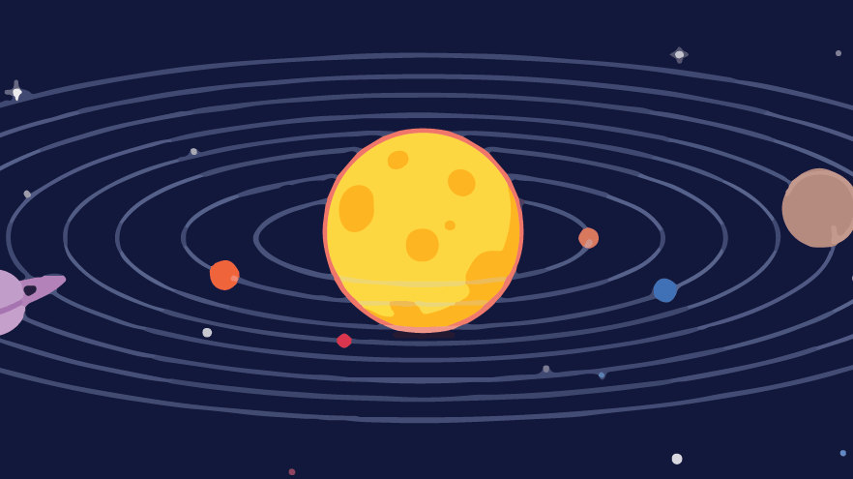

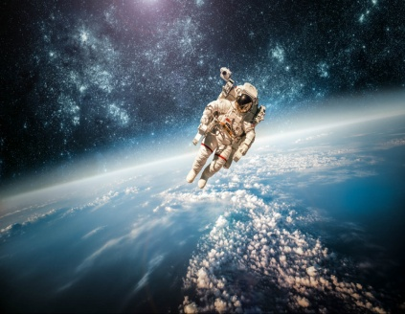

Questions I would like to ask...

Vocabulary we will use:

Dwarf planet

Celestial body

Earth

Astronomical clock

Jupiter

Mars

Mercury

Moon Neptune

Night and day

Orbit

Planets

Pluto

Rotate

Saturn

Solar systems

Sphere

Skills I will use:

* Observation
* Research
* Reflection and evaluation
* Use of IT.
* Art
* Design and make a model
* Maths-scales and measures

