What is special about Brazil and its rainforest?

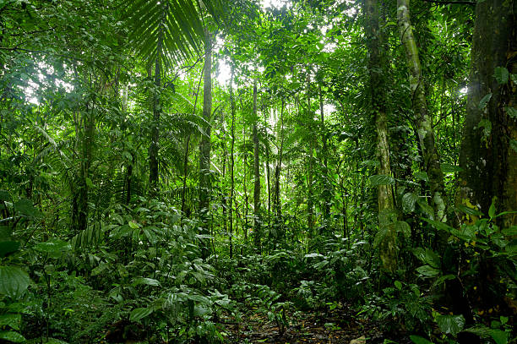
Questions we will explore;
- Where are rainforests located and what are their main features?
- Why are rainforests often in the news and what can we do to help?
- What can you find out about an endangered animal that lives in the rainforest?
- How important is the Amazon to the South American rainforests?
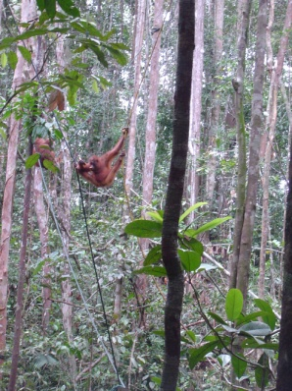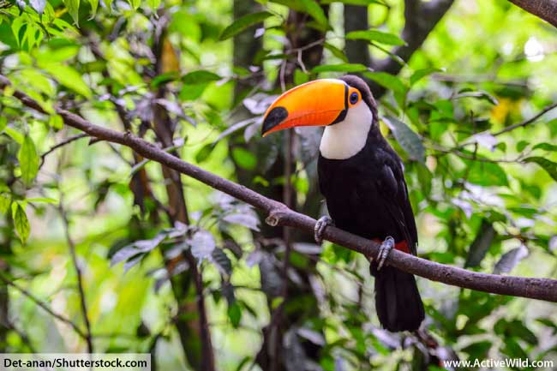
Skills we will use:
- Research including ICT
- Debate and discussion
- Reflection
- Art
- Reading and evaluating
- Atlas work
- Persuasive writing
Vocabulary we will use
rainforest, journeys, destroyed, dense, extinct, eroded, humid, nutrients, regenerated, remote, shrinking, sustainable, tropical, vast
Questions I would like to ask?

