Key Words
trust | To hope and believe in something someone has told you.
Bible | The special book for Christians.
Old Testament | The first part of the Bible.
New Testament | This is a book of the Bible and contains lots of stories.
Holy | To be unique and pure.
Gospel | The Christian message about God.
Word of God | The things that God has said.
miracle | An amazing event.
faith | Trusting in something or someone.
behaviour | The way that we act.
Now….
I can retell some of the stories about Jesus’ miracles
I know that Jesus welcomed everybody and how he wanted me to learn from him.
I can talk about my thoughts and feelings about Jesus.
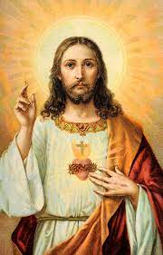
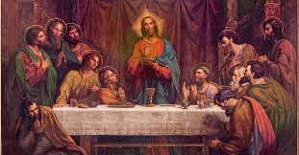
Why was Jesus a friend
to everyone?
?
BIG IDEAS

