Glazebury CE Primary School Head Teacher: Mrs Karen Mowbray BA Hons M Ed Warrington Road, Glazebury, Warrington, Cheshire. WA3 5LZ.
Tel: 01925 763 234 Email: glazebury_primary@warrington.gov.uk

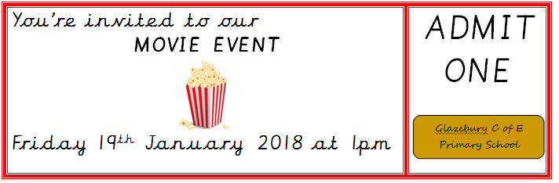

Dear Parents and Carers,
We are proud to inform you that your child has earned 10 or more golden tickets. As a part of our reward scheme created in conjunction with School Council, on Friday 19th January 2018, your child is invited to take part in a DVD event at 1pm. The children have voted and will be watching Despicable Me 3 (U) in the school hall with some special treats. All children will receive a cinema ticket and can bring in some comfortable clothes on the day to change into for the event, such as a onesie. Please bring clothes in a clearly labelled bag with their name on. Younger children may choose to just bring in a teddy or cushion instead of getting changed, if that is easier. This is to acknowledge your child’s achievements on many levels particularly behaviour.
Some children may not have reached 10 golden tickets yet and we will be running this event again around Easter time to allow those children to also gain their reward.
If you have questions about this event, please feel free to ask.
Yours sincerely,

Mrs K Wall
Assistant Head Teacher and Behaviour Lead

